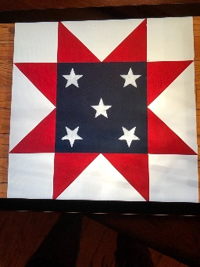  Patriotic | 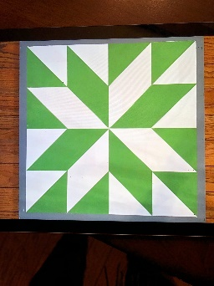  Star | 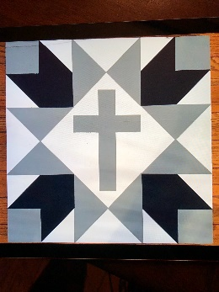  Cross | 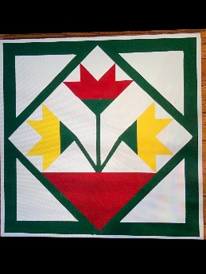  Tulips

Barn Quilt Painting
March 28
10:30am-2pm
Or
3pm-7pm
Scissors or X-Acto knife
Ruler
Yellow or Green Frog Tape (yellow is best)
You may make color substitutions if you bring your own Acrylic paint.

