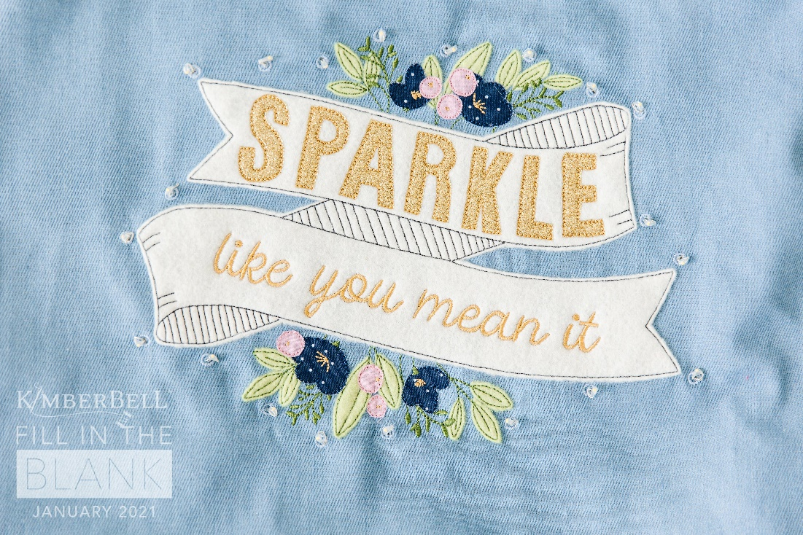
Once Upon A Quilt
where dreams come true
3404 Griffin Road, Fort Lauderdale, FL 33312
Phone: 954-987-8827
www.onceuponaquilt.com

Instructor: Jenifer NeSmith
Date of Class: Thursday, January 7, 2021
Time of Class: 10 AM - 1 PM

Please arrive at your class 10 minutes prior to scheduled time. You may bring a non-perishable snack or lunch to class. Drinks are permitted in a sealed container (screw on caps only)

*** Please bring USB stick for Design and Instructions transfer

Kit (required): Available at OUAQ

Notions:
- Double sided fusible web (Wonder Under, Heat n Bond): (2) 5” x 5” squares
- Steam a Seam: ½” wide strips
- Fray Check
- Optional: 1/8” hole cutter and block
Supplies:
- Sewing Machine with Embroidery Unit & Slide-on Table
- Straight stitch & zigzag throat plates
- Rotary Cutter & See-thru Gridded Ruler
- Sharp Curved Blade Embroidery Snips
- Fabric Shears
- Hand sewing needle and thread
- Marking pen or chalk
- Kimberbell® Paper Tape
- Normal sewing supplies such as pins, extra needles, bobbins, seam ripper, etc.
Hoops:
- Maxi or Jumbo with Template
Stabilizers:
- OESD StabilStick Tearaway
Feet:
- #26 embroidery foot
- #1 or #34 reverse sewing foot
Threads:
Isacord Embroidery Threads ***These are only suggestions. Please just bring something close in color**
Olive Green: #5933 | Denim Blue: #3842 | Dk. Denim Blue: #3743
Pink: #2650 | Gold: #0546
- Bobbin thread & embroidery bobbin case if needed

Important: This class requires the use of your sewing machine it is imperative that you understand how to operate your machine, and that it is in good working order. Please remember to bring your power cord, foot control, work table and accessories to class.***Note: All supplies on this list should be purchased at Once Upon a Quilt to ensure that you have what is required by the instructor to make your class a success. Please purchase your supplies prior to class as our instructors begin at the time the class is scheduled.

