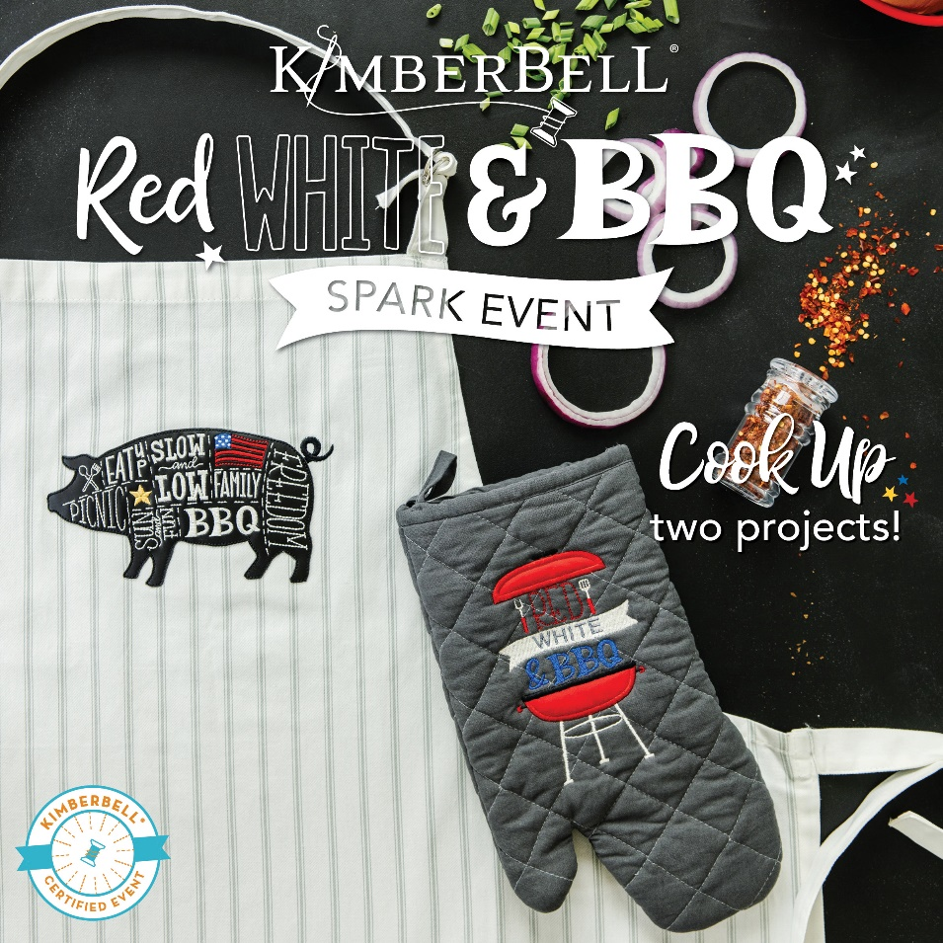
Once Upon A Quilt
where dreams come true, Inc.
3404 Griffin Road/ Fort Lauderdale, FL 33312/ Phone: 954-987-8827/ www.onceuponaquilt.com

Instructor: Jenifer NeSmith
Date of Class: Friday,
June 10th, 2022
Time of Class: 10AM- 2PM

Please arrive at your class 10 minutes prior to scheduled time. Lunch is included.
Drinks are permitted in a sealed container (screw on caps only)

When you arrive at a Kimberbell event, you’ll receive an exclusive sewing bag completely filled with Kimberbell fabric, paper tape, embellishments and more to make 2 amazing event projects. We’ll even cut the stabilizers for you!

Supplies:
- Sewing Machine with Embroidery Unit, Slide-on Table, Foot Pedal, FHS & Power Cord
- Straight stitch & zig-zag stitch throat plates
- Curved Blade Embroidery Snips
- Fabric Shears
- Point Turner or Drum Stick
- Disappearing marking pen or chalk
- Clover Clips
- Rotary Cutter and Gridded See-thru Ruler
- Normal sewing supplies such as pins, hand-sewing needle, extra machine needles, extra bobbins, seam ripper, etc.

Hoops:
- Large Oval
Threads:
- Isacord Embroidery Threads **These are only suggestions. Please just bring something close in color**
Black | White or Off-White | Yellow #1876
Grey #0112 | Blue #3713 | Red #1800
- Bobbin thread & embroidery bobbin case if needed
- Dk. Grey thread & bobbin for standard sewing

Feet:
- #26 embroidery foot
- #37, 57 or 97 quarter inch foot

Important: This class requires the use of your sewing machine it is imperative that you understand how to operate your machine, and that it is in good working order. Please remember to bring your power cord, foot control, work table and accessories to class. ***Note: All supplies on this list should be purchased at Once Upon a Quilt to insure that you have what is required by the instructor to make your class a success. Please purchase your supplies prior to class as our instructors begin at the time the class is scheduled.

