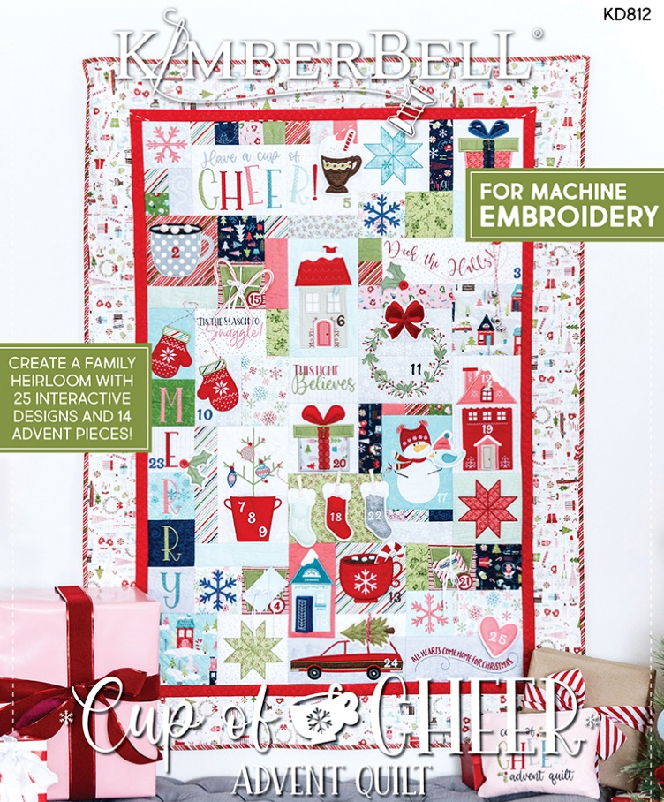
Once Upon A Quilt
where dreams come true, Inc.
3404 Griffin Road/ Fort Lauderdale, FL 33312/ Phone: 954-987-8827/ www.onceuponaquilt.com

Instructor: Jenifer NeSmith
Date of Class: Thursday & Friday,
October 13th & 14th, 2022 AND (if needed) Thursday, October 27th, 2022
Time of Class: 10AM- 4PM

Please arrive at your class 10 minutes prior to scheduled time. You may bring a non-perishable snack or lunch to class. Drinks are permitted in a sealed container (screw on caps only)

Pattern Book, Embellishment Kit & Fabric Kit (Required):
- KD812 Cup of Cheer Advent Quilt by Kimberbell®
- KDKB1264 Cup of Cheer Advent Quilt Embellishment Kit
            - Kimberbell® Cup of Cheer Advent Quilt Fabric Kit
Before coming to class:
- Transfer embroidery designs from the CD to a usable USB stick
For Embroidery Only:
- Cut background fabrics as per “Cut List” on pgs. 4, 5 & 6
- Fuse Fusible Backing or Shapeflex to the wrong side of backgrounds
For Block-by-Block Quilting:
- Download Quilting designs from the Kimberbell website & save to the same USB stick as your embroidery designs
- Fuse Fusible Backing or Shapeflex to the wrong side of applique pieces

Supplies:
- Sewing Machine with Embroidery Unit, Slide-on Table, FHS, Foot Pedal & Power Cord
- Straight stitch & zig-zag stitch throat plates
- Curved Blade Embroidery Snips
- Applique Scissors
- Fabric Shears
- Disappearing marking pen or chalk
- Rotary Cutter and Gridded See-thru Ruler
- OPTIONAL: Orange Pop Rulers in Square & Rectangle
- Normal sewing supplies such as pins, hand-sewing needle, extra machine needles, extra bobbins, seam ripper, etc.
Hoops (the larger your hoop the more you can stitch all at once):
- For Embroidery only: Medium, Lg. Oval/Midi & Mega/Maxi
- For Block-by-Block Quilting: Lg. Oval/Midi, Maxi and/or Jumbo
Stabilizers:
- For Embroidery only: OESD Ultra Clean and Tear Fusible
- For Block-by-Block Quilting: Kimberbell® Lt. Mesh Cut-Away & Low-Loft Batting
- Kimberbell® Lt. Mesh Cut-Away
- Kimberbell® Fusible Backing or Shapeflex
- Kimberbell® Washaway
Thread (Isacord):
Black | Brown #0933 or #1346 | Melon #1840 | Lt. Teal #5050
White | Gold #0821 | Mint #5770 | Teal #4625
Grey #0105, #0142 or #0145 | Red #1800, #1903 or #1904 | Green #5833 or #5933 | Navy #3743
Tan #0672, #0761 or #0874
- Bobbin thread & embroidery bobbin case if needed
Feet:
- #26 embroidery foot

Important: This class requires the use of your sewing machine it is imperative that you understand how to operate your machine, and that it is in good working order. ***Note: All supplies on this list should be purchased at Once Upon a Quilt to insure that you have what is required by the instructor to make your class a success. Please purchase your supplies prior to class as our instructors begin at the time the class is scheduled.

