Once Upon A Quilt
where dreams come true
3404 Griffin Road, Fort Lauderdale, FL 33312
Phone: 954-987-8827
www.onceuponaquilt.com

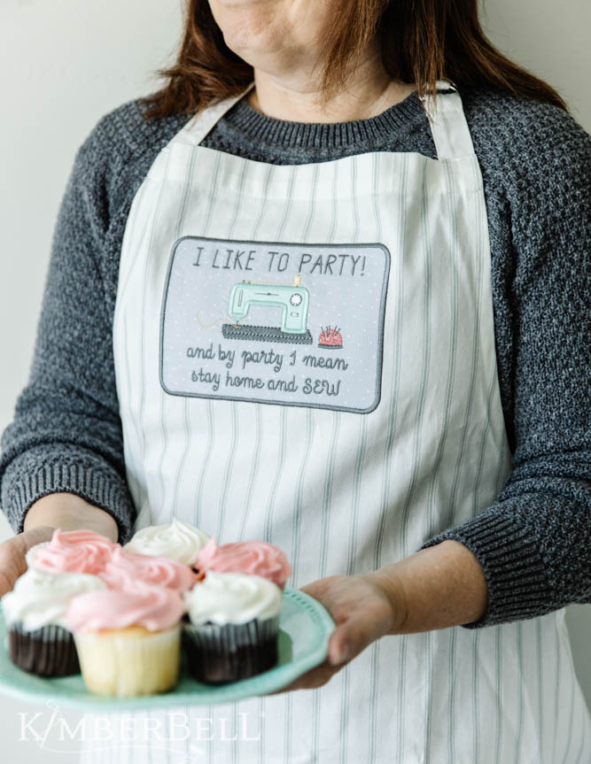

Instructor: Jenifer NeSmith
Date of Class: Thursday, September 1st, 2022
Time of Class: 10 AM - 1 PM
OUAQ’s Kit
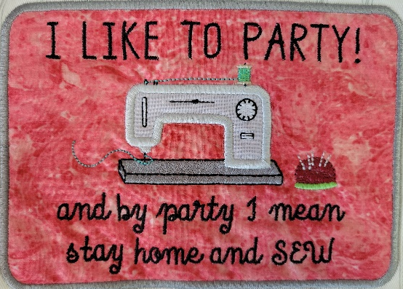

Please arrive at your class 10 minutes prior to scheduled time. You may bring a non-perishable snack or lunch to class. Drinks are permitted in a sealed container (screw on caps only)

*** Please check your email for the link to download the Design and Instructions ***

Kits: Available at OUAQ

Supplies:
- Sewing Machine with Embroidery Unit, Slide-on Table, Foot Pedal, Power Cord & FHS
- Straight stitch & zigzag stitch throat plates
- Rotary Cutter & See-thru Gridded Ruler
- Sharp Curved Blade Embroidery Snips
- Fabric Shears
- Disappearing marking pen or chalk
- Kimberbell® Paper Tape
- Normal sewing supplies such as pins, extra needles, bobbins, seam ripper, etc.

Hoops:
- Lg. Oval

Stabilizers: (enough for 1 hooping)
- Kimberbell® Wash-Away Sticky-Back
- Kimberbell® Fusible Backing or Pellon ShapeFlex: (1) pc. 5 1/2” x 7 1/2” & (1) 2” x 3”

Feet:
- #26 embroidery foot

Threads:
- Isacord Embroidery Threads ***These are only suggestions. Please just bring something close in color***
Black | Med. Grey #4073 | 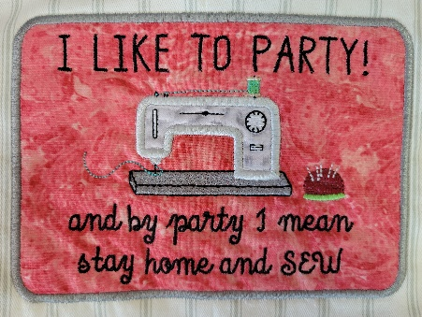  Color for thread
White | Dk. Red #2022 (Pincushion) | Accent color for thread
Lt. Grey #3770 | Tan #0761 (Spool Ends)
- Matching or regular Bobbin thread & embroidery bobbin case if needed

Important: This class requires the use of your sewing machine it is imperative that you understand how to operate your machine, and that it is in good working order. Please remember to bring your power cord, foot control, work table and accessories to class.***Note: All supplies on this list should be purchased at Once Upon a Quilt to ensure that you have what is required by the instructor to make your class a success. Please purchase your supplies prior to class as our instructors begin at the time the class is scheduled.

