
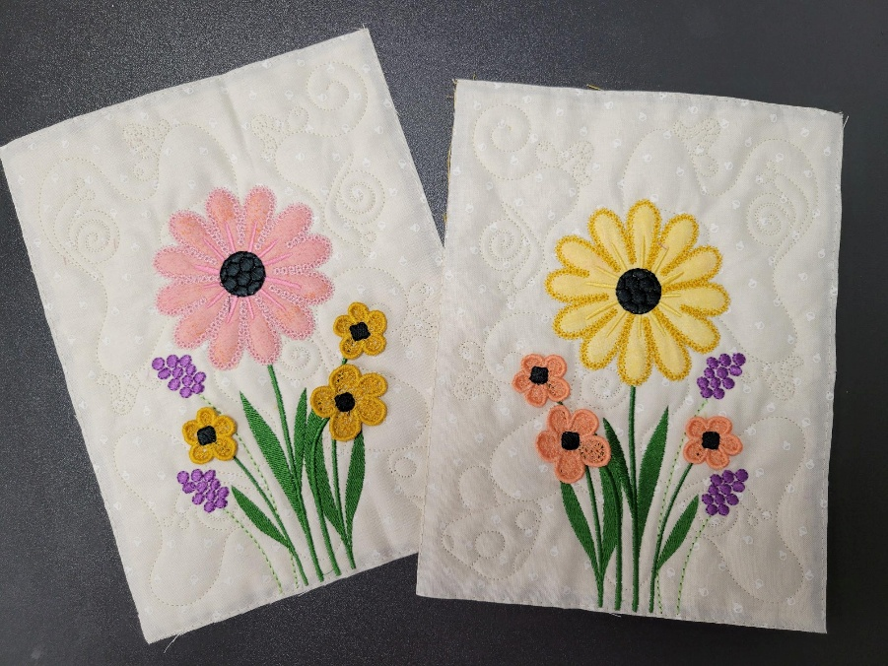

Instructor: Jenifer
Once Upon A Quilt
where dreams come true
3404 Griffin Road, Fort Lauderdale, FL 33312
Phone: 954-987-8827
www.onceuponaquilt.com

Date of Class: Thursday, October 2nd, 2025
Time of Class: 10 AM - 1 PM

Please arrive at your class 10 minutes prior to the scheduled time. You may bring a non-perishable snack or lunch to class. Drinks are permitted in a sealed container (screw on caps only)

*** Please check your email for the link to download the Design and Instructions ***

Kits: Provided by OUAQ

Supplies:
- Sewing Machine with Embroidery Unit, Slide-on Table, Foot Pedal, Power Cord & FHS
- Straight stitch & zigzag stitch throat plates
- Sharp Curved Blade Embroidery Snips / Applique Scissors
- Rotary Cutter & See-thru gridded ruler
- Disappearing marking pen or chalk
- Pins and/or Clips
- Kimberbell® Paper Tape
- Optional but recommended: Kimberbell® Orange Pop Rulers Square & Rectangle
- Normal sewing supplies such as pins, extra needles, extra bobbins, seam ripper, hand sewing needle, etc.

Hoops:
- Medium
- Large Oval (Design Only)
- Maxi if Quilting Block-by-Block (Files are included for both Block-by-Block Quilting and Clear-Blue Tile Quilting)

Stabilizers:
- Kimberbell® Wash Away Mesh (2 layers to fit in medium hoop)
- Kimberbell® Lt. Mesh Cut-Away
- Kimberbell® Fusible Backing or Pellon Shapeflex: Small pieces to back applique fabrics
- If Quilting Block-by-Block: Kimberbell® Project Batting or Batting: (2) 8 ½” x 10 ½”

Feet:
- #26 Embroidery foot

Threads:
Cream #0870 for Quilting | Yellow #0713 | Dk Yellow #0704 | Charcoal #4174
Lt. Green #5832 | Green #5633 | Purple #2912 OR | Blue #3630
Lt. Pink #2155 | Pink #2530
- Isacord Embroidery Threads
- Bobbin thread & embroidery bobbin case if needed

Important: This class requires the use of your sewing machine. It is imperative that you understand how to operate your machine and that it is in good working order. Please remember to bring your power cord, foot control, worktable and accessories to class. ***Note: All supplies on this list should be purchased at Once Upon a Quilt to ensure that you have what is required by the instructor to make your class a success. Please purchase your supplies prior to class as our instructors begin at the time the class is scheduled. #

