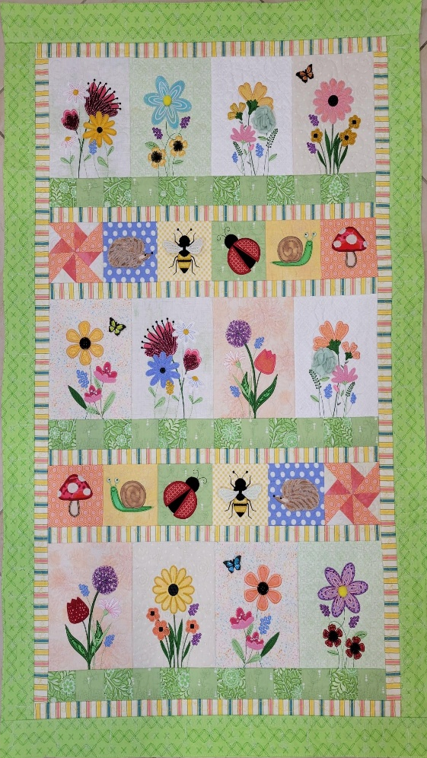

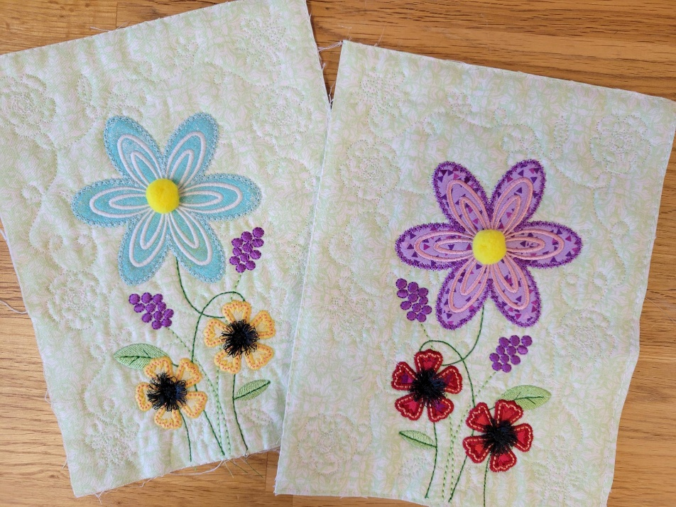

Once Upon A Quilt
where dreams come true
3404 Griffin Road, Fort Lauderdale, FL 33312
Phone: 954-987-8827
www.onceuponaquilt.com

Instructor: Jenifer
Date of Class: Thursday, November 6th, 2025 (LAST CLASS OF THE YEAR!)
Time of Class: 10 AM - 1 PM

Please arrive at your class 10 minutes prior to the scheduled time. You may bring a non-perishable snack or lunch to class. Drinks are permitted in a sealed container (screw on caps only)

*** Please check your email for the link to download the Design and Instructions *** Don’t forget your USB stick ***

Kits: Provided by OUAQ

Supplies:
- Sewing Machine with Embroidery Unit, Slide-on Table, Foot Pedal, Power Cord & FHS
- Straight stitch & zigzag stitch throat plates
- Sharp Curved Blade Embroidery Snips / Applique Scissors
- Rotary Cutter & See-thru gridded ruler
- Disappearing marking pen or chalk
- Pins and/or Clips
- Kimberbell® Paper Tape
- Optional but recommended: Kimberbell® Orange Pop Rulers Square & Rectangle
- Normal sewing supplies such as pins, extra needles, extra bobbins, seam ripper, hand sewing needle, etc.

Hoops:
- Large Oval (Design Only)
- Maxi if Quilting Block-by-Block and for quilting Borders

Stabilizers:
- Kimberbell® Lt. Mesh Cut-Away
- Kimberbell® Fusible Backing or Pellon Shapeflex: Small pieces to back applique fabrics
- If Quilting Block-by-Block: Kimberbell® Project Batting or Batting: (2) 8 ½” x 10 ½”
- Border Quilting Block-by-Block: (1) 8” x 70”, (1) 7” x 35” and (1) 7” x 48” –Can be pieced

Feet:
- #26 Embroidery foot

Threads:
White #0101 | Yellow #0713 | Red #1902 | Charcoal #4174
Lt. Green #5832 | Green #5633 | Purple #2912 | Blue #3630
Lt. Pink #2155 | Coral #1352 | Lt. Turquoise #5050
- Isacord Embroidery Threads
- Bobbin thread & embroidery bobbin case if needed
- Water-Soluble bobbin thread: Ex: Vanish™ by Superior or bobbin with contrasting thread

Quilting your borders:

Inner Border:
- Cut the ½ yard of fabric into (2) 9” x WOF pieces.
- Sew short end to short end
- Open design kdq524-border-spring-3, 1 x 14 in your maxi hoop.
- Move design as far to the left as possible.
- Duplicate the design 3 times to total 4. Recenter entire design.
- Highlight the 3 spools in the stitching screen to reduce color changes
- Stitch design 5 times as per instructions
- Cut strip into (4) 1 ½” x 24 ½” pcs.
(2) 1 ½” x 26 ½” pcs.
(2) 1 ½” x 42 ½” pcs.

Outer Borders:
- Cut the ½ yard of fabric into (3) 5 ½” to 6” wide x WOF pieces.
- Sew the short ends of 2 strips together. Keep one strip separate.
- Open design kdq524-border-spring-3, 2 x 14 in your maxi hoop.
- Move design as far to the left as possible.
- Duplicate the design 1 time to total 2. Recenter entire design.
- Highlight the 3 spools in the stitching screen to reduce color changes
- Start with the single strip. Stitch design 3 times. Cut strip into (2) 2 ½” x 30 ½” pcs.
- Stitch double strip. Stitch design 4 times. Cut strip into (2) 2 ½” x 44 ½” pcs.

Important: This class requires the use of your sewing machine. It is imperative that you understand how to operate your machine and that it is in good working order. Please remember to bring your power cord, foot control, worktable and accessories to class. ***Note: All supplies on this list should be purchased at Once Upon a Quilt to ensure that you have what is required by the instructor to make your class a success. Please purchase your supplies prior to class as our instructors begin at the time the class is scheduled. #

