where dreams come true, Inc.

3404 Griffin Road

Fort Lauderdale, FL 33312

Phone: 954-987-8827 www.onceuponaquilt.com

Gathering Wild Flowers

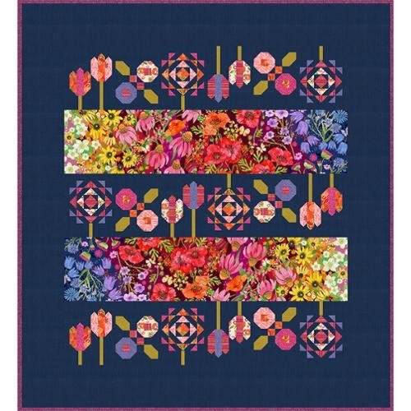

Size 53 ¾”x 57 ½”

Instructor: Maria Figini

9/16 – 9/23 and 9/30, 2025

10:00AM – 3:00PM

Kit Required: Fabrics Kit and Pattern available at the Once Upon A Quilt

Supplies: Sticky notes, pencil and notebook

Marking Pencils Sew-line preferred

Rotary Cutter (with sharp blade)

Cutting Mat

Rulers Creative Grid ONLY:

1. 6 ½” x 24”
2. 2 ½”x 12 ½”

2) 6 ½” square

3) 12 ½” square

Glass head pins

Seam ripper

Aurifil thread (medium grey or ecru)

Small bags Ziploc max 20

Small Post - it

Sewing Machine

Please remember to bring your power cord, foot control, work table and accessories to class. We rent classroom Bernina machines for $5.00 per session. These machines are reserved on a first request basis. .

\*\*Note: All supplies on this list should be purchased at Once Upon a Quilt to ensure that you have what is required by the instructor to make your class a success. Please purchase your supplies prior to class as our instructors begin at the time the class is schedule.