where dreams come true, Inc.

3404 Griffin Road
Fort Lauderdale, FL 33312
Phone: 954-987-8827 www.onceuponaquilt.com
Driftwood My Fair Lady
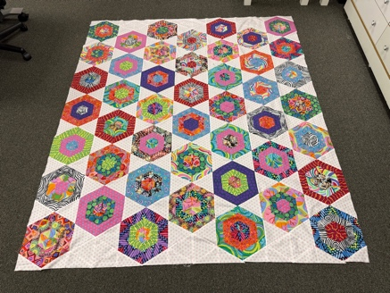

Instructor: Maria Figini
March 21st and April 1st, 2026
10:00AM – 3:00PM

Book: Kaffe Quilts Again by Kaffe Fassett

Fabrics: 14 Fabrics in a good variety of colors and prints - ½’ yard each
Background - 2 ½’ yds.

Supplies: Rotary Cutter and Mat
Creative Gride:
Ruler 6 ½”x 24”
Ruler 60 Degree 8 ½” – CGRT60
Ruler 1 ½” x 6 ½”
Straight pins
Aurifull Thread beige
Scissors for fabric
Sewing Machine

HOMEWORK - Cutting
- Background – 10 strips @ 5 ½” and 4 strips @ 3 ½”

- From 14 Fabrics: a variety of colors – 24 strips @ 2 ½” and 48 strips @ 2”

*Important: If this class requires the use of your sewing machine it is imperative that you understand how to operate your machine, and that it is in good working order. Please remember to bring your power cord, foot control, work table and accessories to class. We rent classroom Bernina machines for $5.00 per session. These machines are reserved on a first request basis.
**Note: All supplies on this list should be purchased at Once Upon a Quilt to ensure that you have what is required by the instructor to make your class a success. Please purchase your supplies prior to class as our instructors begin at the time the class is schedule

