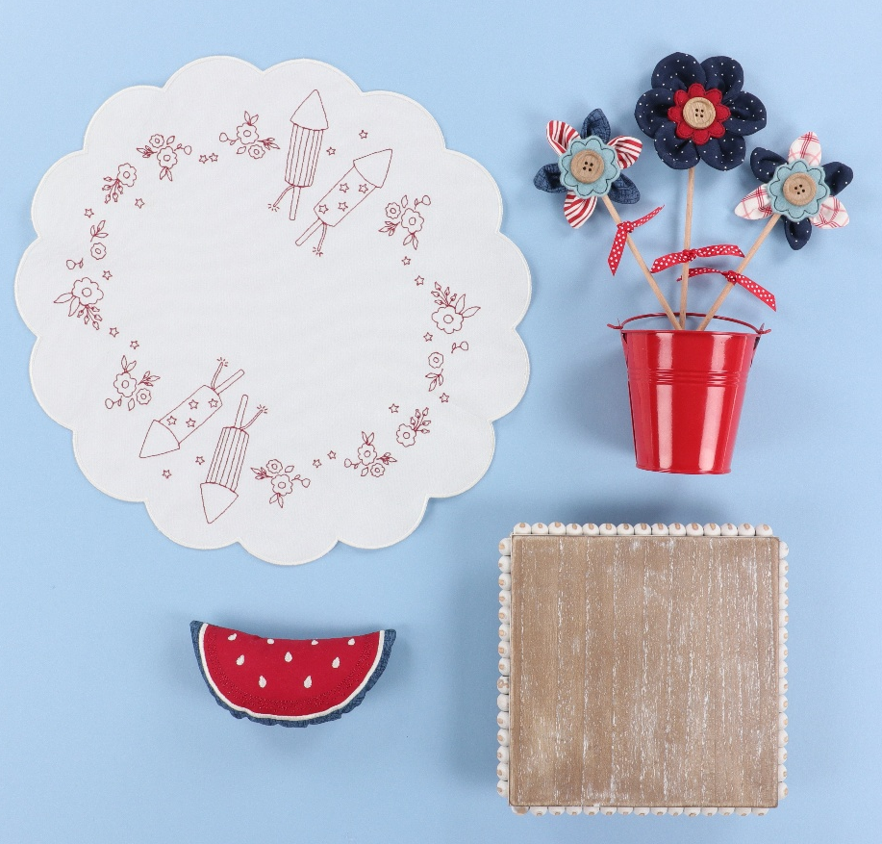
Once Upon A Quilt
where dreams come true, Inc.
3404 Griffin Road/ Fort Lauderdale, FL 33312/ Phone: 954-987-8827/ www.onceuponaquilt.com


Instructor: Jenifer NeSmith
Date of Class: Friday, May 15th, 2026
Time of Class: 10AM- 4PM

Please arrive at your class 10 minutes prior to scheduled time. Lunch is included.
Drinks are permitted in a sealed container (screw on caps only)

When you arrive at a Kimberbell event, you’ll receive an exclusive sewing bag filled with Kimberbell fabric, paper tape, embellishments & more to make these 3 projects. We’ll even cut the stabilizers for you!

Kits & Lunch: Provided by OUAQ

Supplies:
- Sewing Machine with Embroidery Unit, Slide-on Table, Foot Pedal, FHS & Power Cord
- Straight stitch & zig-zag stitch throat plates
- Curved Blade Embroidery Snips
- Sharp Scissors for Cutting Applique
- Fabric Shears and pinking shears
- Dental Floss or strong thick thread
- Hand sewing needle with large eye
- Point turner
- Disappearing marking pen or chalk
- Sewing Clips
- Normal sewing supplies such as pins or clips, extra machine needles, extra bobbins, hand sewing needle, seam ripper, etc.

Hoops:
- Lg. Oval (5” x 7”)
- Mega/Maxi (6” x 10”)
Threads:
- Isacord Embroidery Threads **These are only suggestions. Please just bring something close in color**
White | Linen #0870 | Red #1902 | Blue #3743
- Bobbin thread & embroidery bobbin case if needed

Feet:
- #26 embroidery foot


Important: This class requires the use of your sewing machine it is imperative that you understand how to operate your machine, and that it is in good working order. Please remember to bring your power cord, foot control, work table and accessories to class. ***Note: All supplies on this list should be purchased at Once Upon a Quilt to insure that you have what is required by the instructor to make your class a success. Please purchase your supplies prior to class as our instructors begin at the time the class is scheduled.

