where dreams come true, Inc.

3404 Griffin Road

Fort Lauderdale, FL 33312

Phone: 954-987-8827 www.onceuponaquilt.com

All is Bright

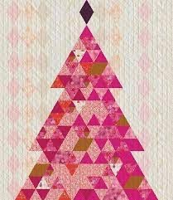

Instructor: Maria Figini

October 11th and October 25th, 2025

10:00AM – 3:00PM

Kit Required: Fabrics Kit and Pattern required to be in this class

Supplies: Rotary Cutter and Mat

Creative Grid: Ruler 6 ½” x 24”

Straight pins

Aurifull Thread beige

Scissors for fabric

Seam ripper

Small Post – it notes

Sewing Machine

*Important: If this class requires the use of your sewing machine it is imperative that you understand how to operate your machine, and that it is in good working order. Please remember to bring your power cord, foot control, work table and accessories to class. We rent classroom Bernina machines for $5.00 per session. These machines are reserved on a first request basis. .

**Note: All supplies on this list should be purchased at Once Upon a Quilt to ensure that you have what is required by the instructor to make your class a success. Please purchase your supplies prior to class as our instructors begin at the time the class is schedule.

HOMEWORK: Before attending the class:

Pull the page with colored fabric ( fabric guide)with their letters from the pattern.

Make cutting as follow:

**FABRIC # STRIP 3 ½” STRIPS 6 ½”**

**A - 2**

**B 1 3**

**C 1 2**

**D - 2**

**E 1 1**

**F - 3**

**G 1 5**

**H - 2**

**I - 2**

**J - 1**

**K - 3**

**(L) nothing**

**M 1 1**

**N - 3**

**O - 16**

**P 1 1**

**Q - 1**