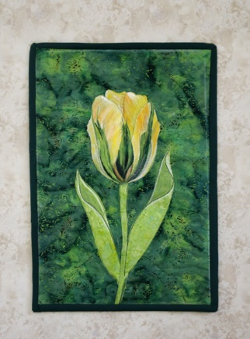
Creating a Flower Wall Quilt from a Photo
Meg Dalton

In this workshop we will turn a photo of a tulip into a wall quilt using a light pad, fabric and acrylic paint. We will be making a raw-edge applique of the flower and will complete the quilt top. You do not need your sewing machine, as you will complete your quilt at home.

Materials List for Making a Painted Flower

*1 Fat Quarter of background fabric
*1 fat eighth of a green fabric for leaves and stem
*1 fat eighth of main color for flower
*1 fat eighth of darker shade of the chosen flower color
Lite Steam-a-Seam or some similar double sided fusible web
Small, sharp scissors for cutting fabric. Curved works best
Paper scissors for cutting the fusible web

I will supply paint, brushes and other supplies needed for this project. A $5 fee for materials will be collected at the time of the workshop.

*Note – I have found that batik fabric works well with paint and raw-edge applique.

