Class requirements: 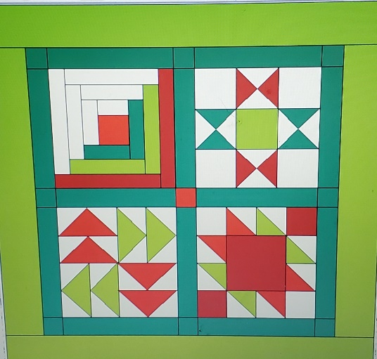
(Fabric requirements based on green and red sample) This part can seem overwhelming when you see all the amazing fabrics the shop has to offer. The staff is there to help you, so don’t hesitate to ask. I suggest that you choose one or two favorites and let the shop staff guide you with some options. Please note that the colors listed below refer to the picture above – choose any colors you like best! You will have more than enough fabric for this project
White – 1 yard
Lt. Green – 1/2 yard
Green – 2/3 yard
Red – 1/2 yard
Dark Red – 1/2 yard
Sashing - 1/2 yard (Green)
Border – 2/3 yard (Lt. Green)
Backing – 1 1/3 yard (This can be anything you like!)
Binding – 1/3 yard (This should coordinate with the front. It can be the same as the border or one of the other colors in the blocks.)
Batting – 1 1/3 yard (Crib size 45” x 60” packaged)
50 wt Cotton thread in a neutral or coordinating color

Sewing machine in good working order.
1/4” sewing foot for your machine. This is extremely helpful, but not required.
Self-healing cutting mat
Acrylic quilting ruler(s) My favorites and most used are 6 ½“ x 13”, 6” x 24”, and 12 ½” square.
Rotary cutter, Fabric scissors and small snips for threads, Small iron , Pins, seam ripper,
Fabric pen or pencil (such as Sewline), pins.
Stiletto, safety pins, binding clips

