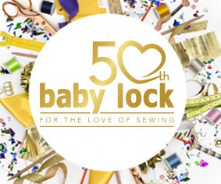  October 12th&13th  Baby Lock's 50th Anniversary Celebration Regional Event  Sewing and Serging!  Two fun filled days of hand-on sewing, serging & embroidery with Two Baby Lock Educators - Missy Billingsley & Pam Mashie - using the latest Baby Lock machines. The projects are an embroidered notebook cover and a serged hanging organizer. The event is being held on Friday & Saturday, October 12 & 13, from 9:30 am to 4:30 pm at the Masonicare at Ashlar Village, 74 Cheshire Rd, Wallingford, CT 06492. Fee for the 2-Day event is $149, which includes project kits, use of the machines, lunch & hand-outs. One-day event option available for $99.00.  Glastonbury Southington Orange  860-633-0721 860-793-6640 203-878-1654  277 Hebron Ave 995 Queen Street 196 Boston Post Rd | Baby lock certified instructors!  ────  Incredible hands on experience!  ────  Two Great Projects!  ────  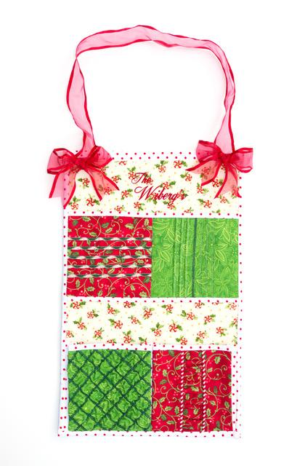  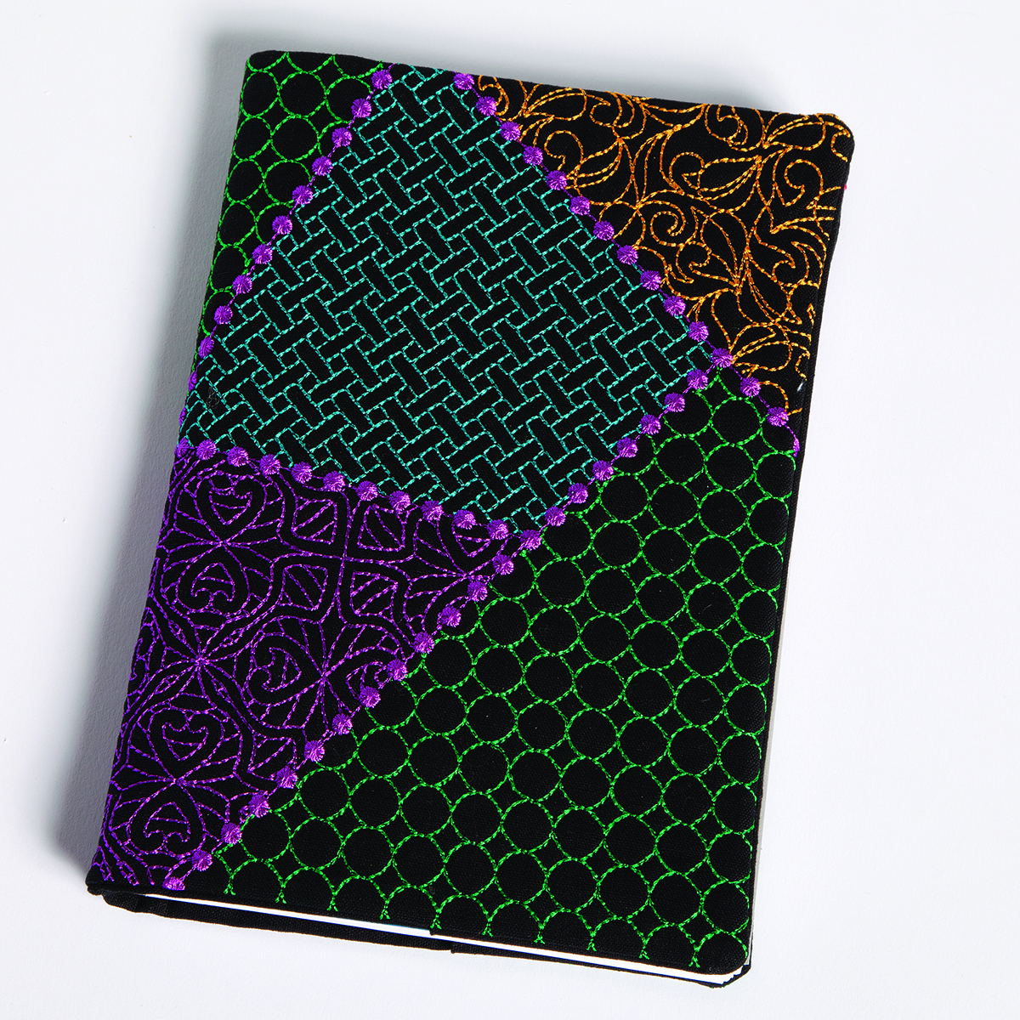  ────  Serged Hanging Organizer & Embroidered Notebook Cover  Masonicare at ashlar village  74 Chesire road,  WALLINGFORD, CT 06492

