Rag-a-Muffin Rug
Class Supply List

After this 2-part class you will have a darling rag rug for your home!
Choose your favorite Jelly roll. Prior to class, sew all the strips together end-to-end; then press the entire strip, wrong-sides-together, down the middle. Fold and bring to class.
Other fabrics needed:
- 1 yard fabric for top of rug base. This fabric will not show.
- 1 yard fabric for the back
- Batting to fit (1 yard). If you want a thicker rug, double the batting.
- ½ yard binding.

Also, bring to class:
- Your sewing machine with a walking foot, if you have one it’s much easier.
- Basic sewing kit
- Sharp to the point scissors. Light-weight will be an advantage.
- All your fabrics
- Thread to coordinate & extra bobbins

Taught by: Carla Gray

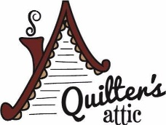

2155 Orchard Dr., Bountiful, UT
801-292-1710
www.quiltersattic-utah.com

