Jelly Roll Tree Skirt
Class Supply List

This is a 2-part class and will turn the popular Jelly Roll Rug into a darling tree skirt.
Choose your favorite Christmas Jelly Roll and pick up a 50-yd roll of Katahdin batting. If you’ve made a jelly roll rug before, you won’t need to attend the first class… just come prepared to sew your skirt together at the second class. If you haven’t sewn a jelly roll rug before, we’ll show you how to begin at the 1st class.

Bring your sewing machine to the classes, plenty of thread to match or contrast (your choice).

Taught by: Carla Gray
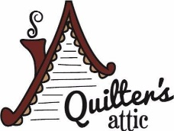

2155 Orchard Dr., Bountiful, UT
801-292-1710
www.quiltersattic-utah.com

