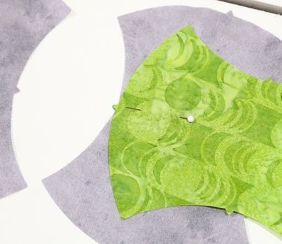
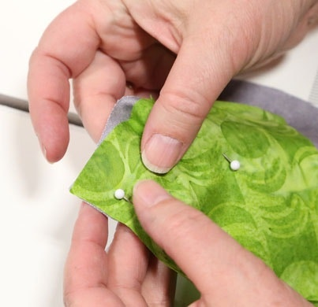
1. Lay two Apple Cores out like the picture below. Use the notches to match one piece to the other. Pin at the center.
2. Next, line up the corners and add another pin.
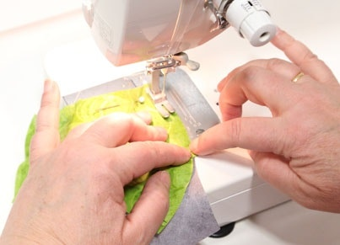
3. Get yourself situated at your sewing machine. Start sewing at the pinned corner towards the center pin. Use a ¼" seam.
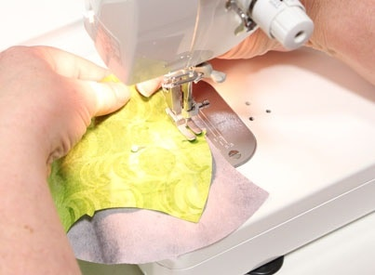
4. When you reach the center, take a second to stop, and line the bottom two corners up with one another.
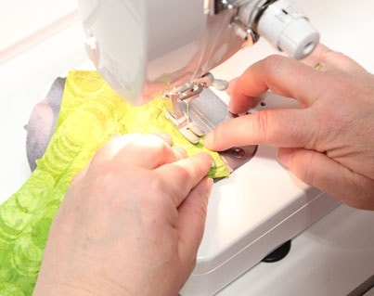
5. Keep sewing...
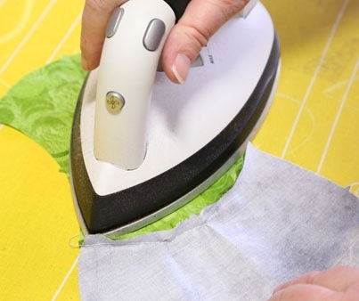 6.Pressyour seams! 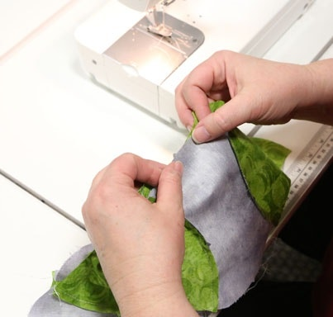
7. Continue joining your Apple Cores together until your rows reach your desired size. Just like square patchwork, your rows are joined together. Use the notches to help line things up for pinning. 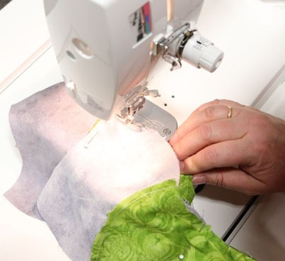
8. Sew the long seam…
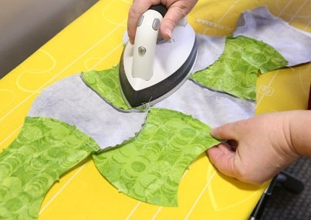
9. Press...
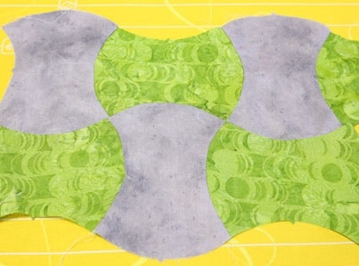
10. And you've got the start to a cozy Apple Core quilt that will wow your friends and family!
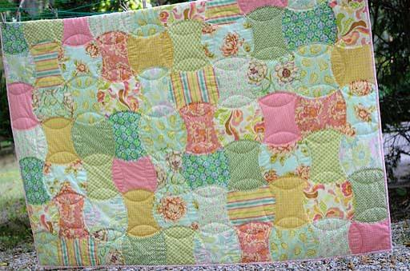
11. You can trim your edges straight
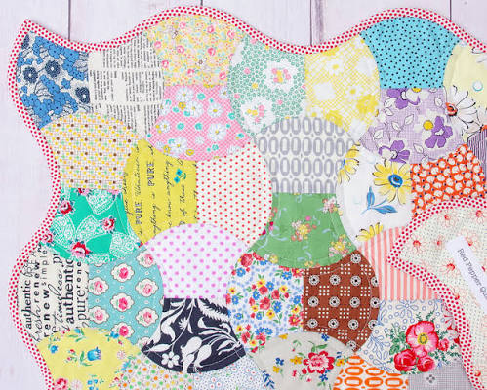
12. Or use a bias binding to bind around the curves. Here is a tutorial that I used for a continuous bias binding without marking or cutting with scissors. https://youtu.be/j4NHseVkF30?si=Tx3Ex1n-CB94GSqk

