Saturday Sampler Tutorial
2018
There are 64 units in this block. That is a lot of seams! The more seams you have, the more chance you have of coming up with an inconsistent measurement for the block. There are at least 40 HST squares in this block. There are a number of methods for constructing half square triangle squares and you are certainly welcome to use any one of them that you feel comfortable with. After putting together 14 blocks I found that the method I’m showing you here worked best for me.
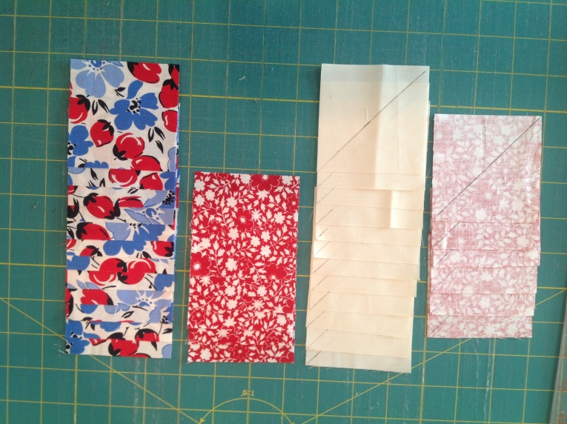
Cut the required number of 3” squares. Pair them up, right sides together, and draw a diagonal line on the wrong side of one of them.
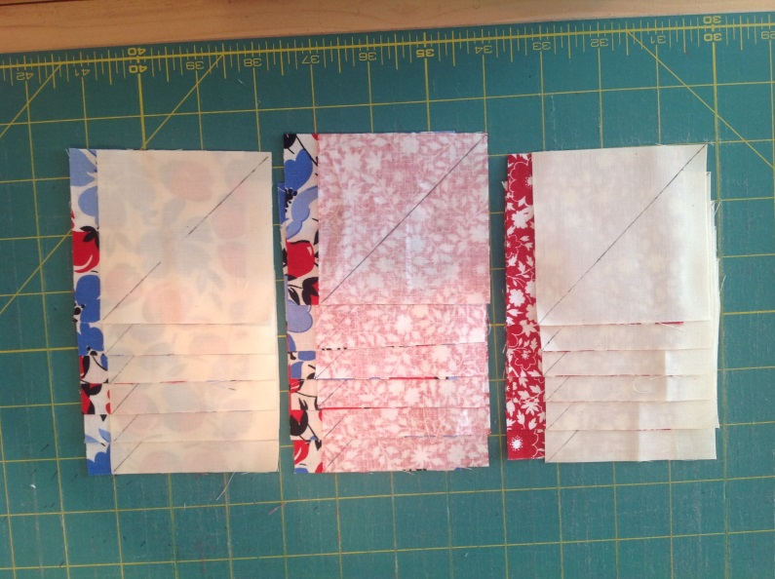
Sew ¼” on both sides of the line. This can be done by chain piecing all 20 pairs on one side, turning them around, and chain piecing on the other side of the line.
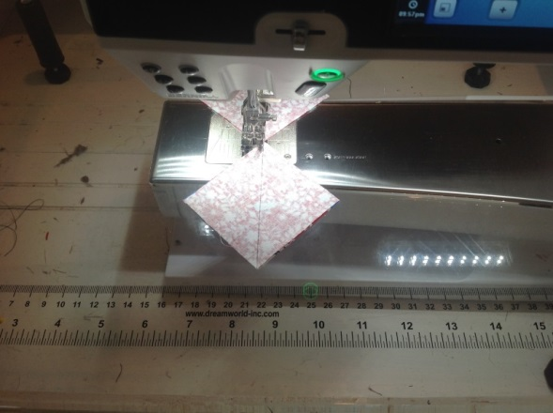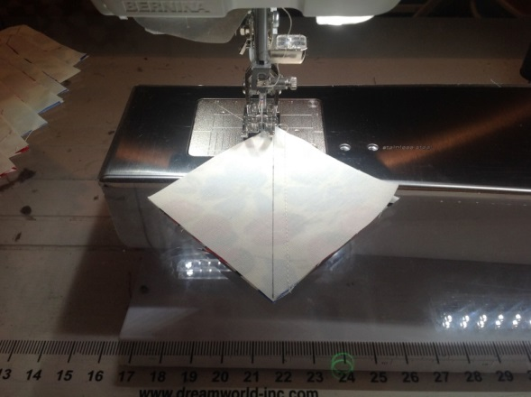

Take the stack to the cutting mat and cut each one on the diagonal line. Press open.

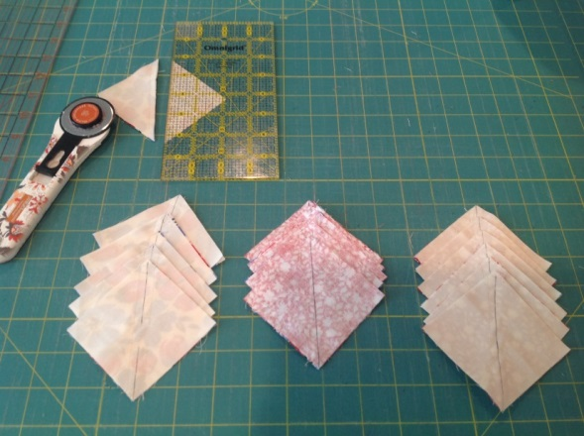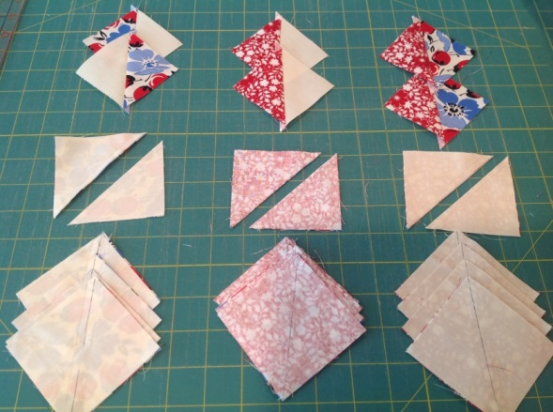
At this point you should have 12 of each color (2) and a background HST and 12 of the two color HST and 4 of the pinwheel corners.
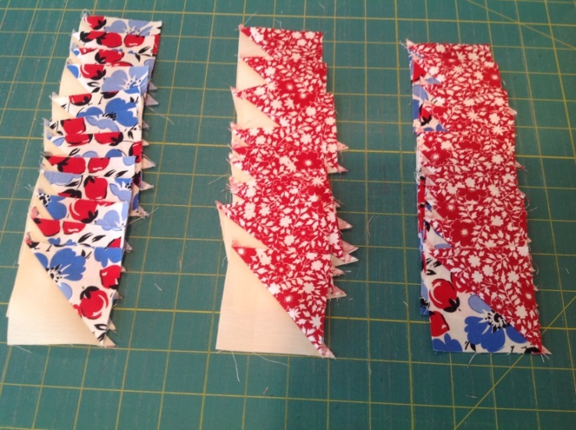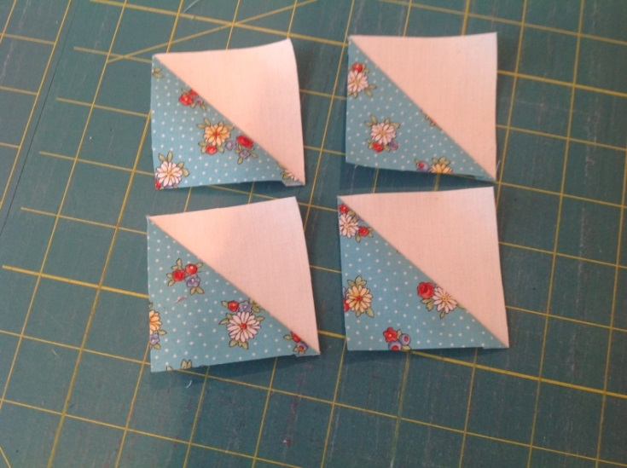

Next comes what I think is the most important step. If you started with 3” squares, your HST’s will need to be trimmed down to 2 ½”. I highly recommend doing this, rather than cutting your strips initially to yield a 2 ½” square when you finish sewing, cutting and pressing. Even if you’re a few threads off, either too big or two small, multiplied by 14 seam allowances, the results will be inconsistant. Whereas if you take the time to square these blocks at this point, it saves a lot of problems down the road.
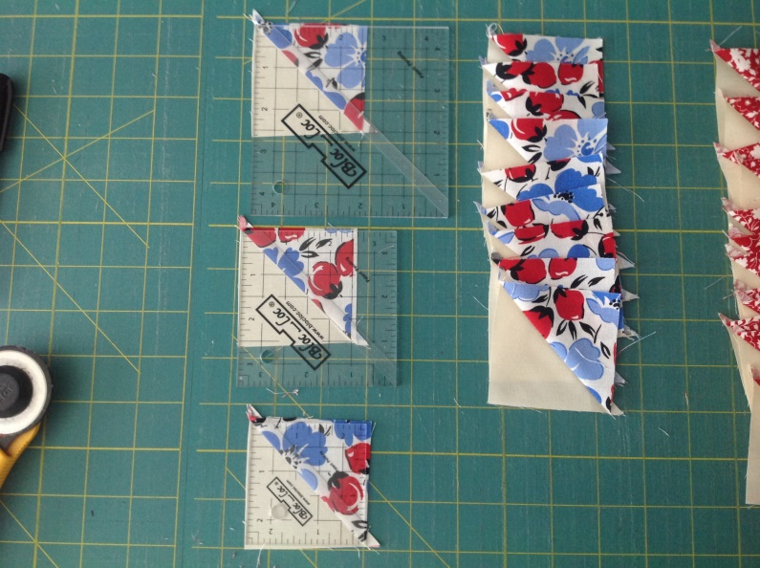
When you have finished squaring up the HSTs, lay the frame out using the diagram you were given with the monthly kit for color placement.
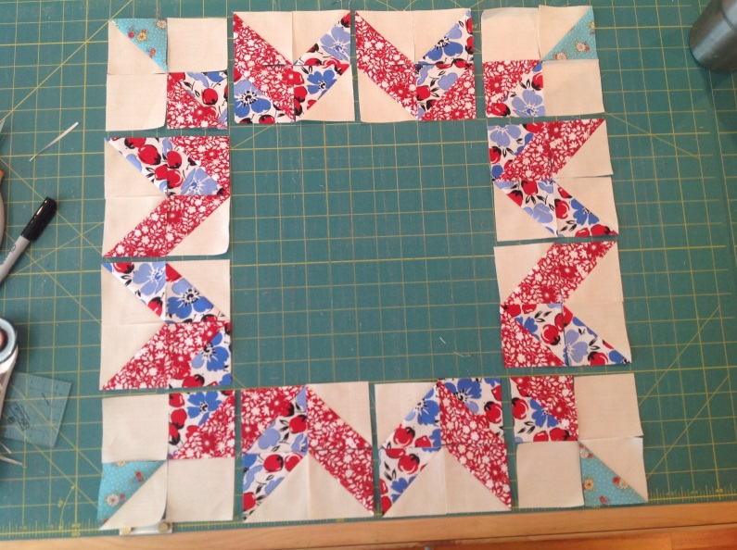
Sew together each 4 patch and put them back in the layout. (Start out doing it this way to avoid confusion.) When you pick up the top pair and stitch it together, finger press the seam allowance to the left side (as you are looking at the right side of fabric). When you do the bottom pair, press to the right. The seams will nest when you sew the two pairs together.

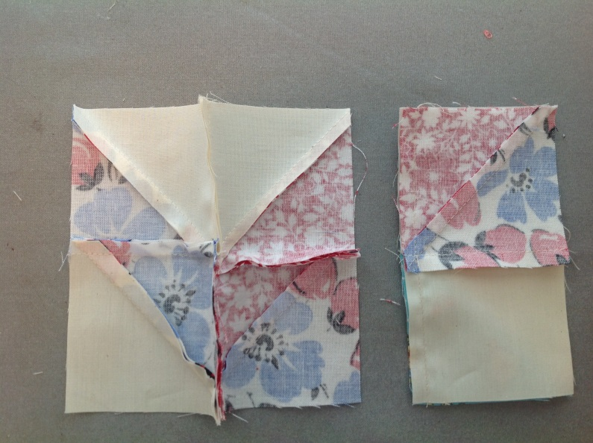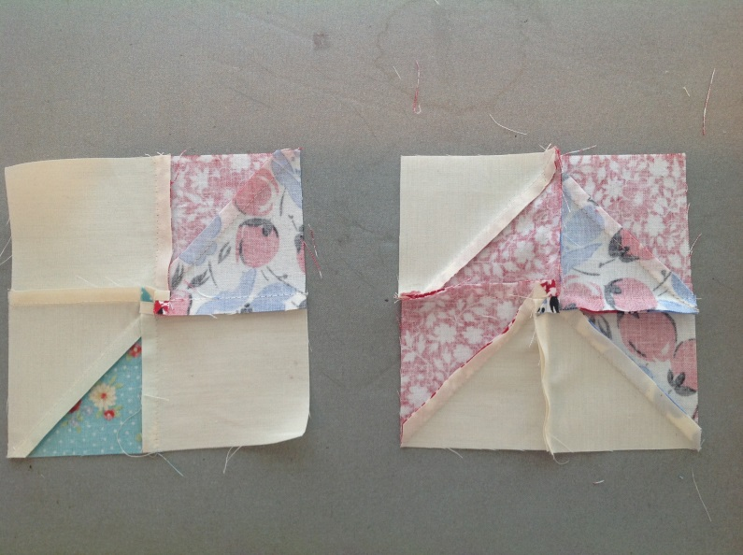
When you press the 4 patches use the swirl press method. If you flip the block to the wrong side, the top seam should be finger pressed to the right. (Left from the front and right from the back.) The bottom seam pressed to the left. Press the horizontal seam on the left up, and the part on the right down. This should give you a cute little square at the center intersection.

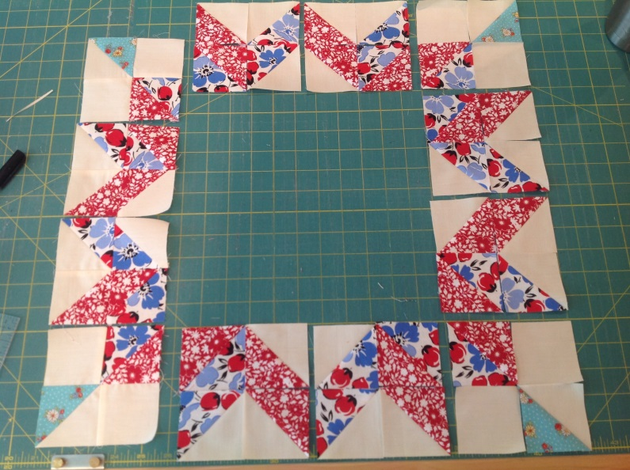
Complete all the 4 patches together, press them, and put them back in position. Now sew together the four right and left side 4 patches, and the top and bottom two 4 patches.
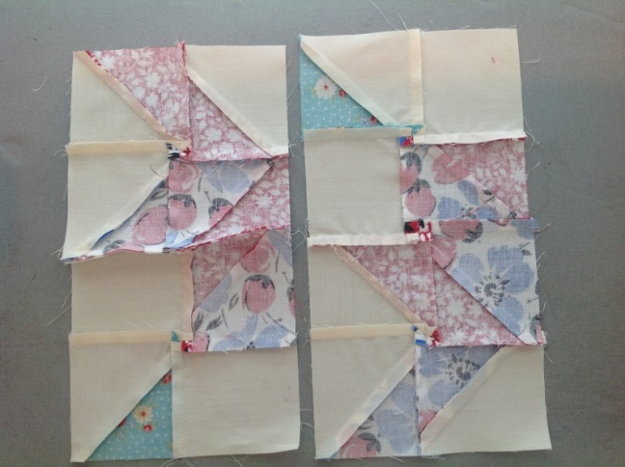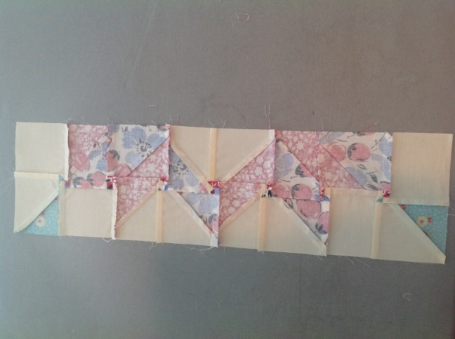
When pressing the seams between the 4 patches, use the same swirl method.
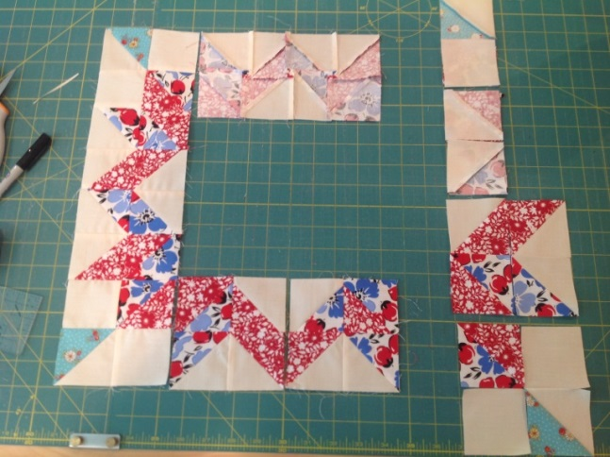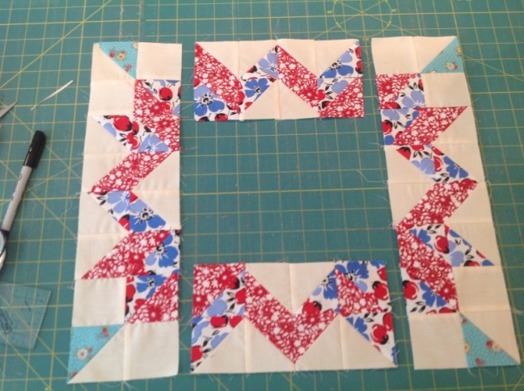
Stop at this point until you have constructed the 8” (finished size) center block.
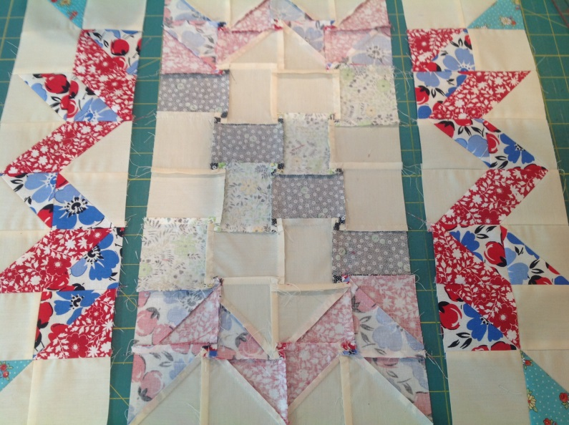
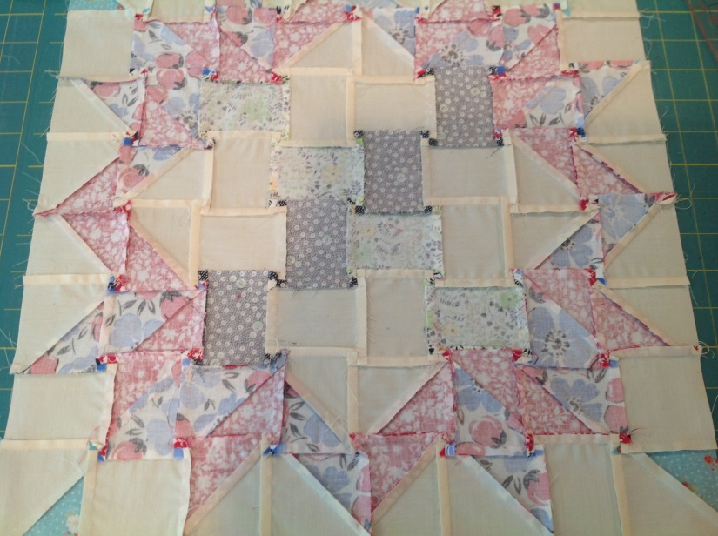

If you press and square up the blocks like this, when it comes time to sew the blocks together, all the seams will nest and completing this quilt will be a breeze!

