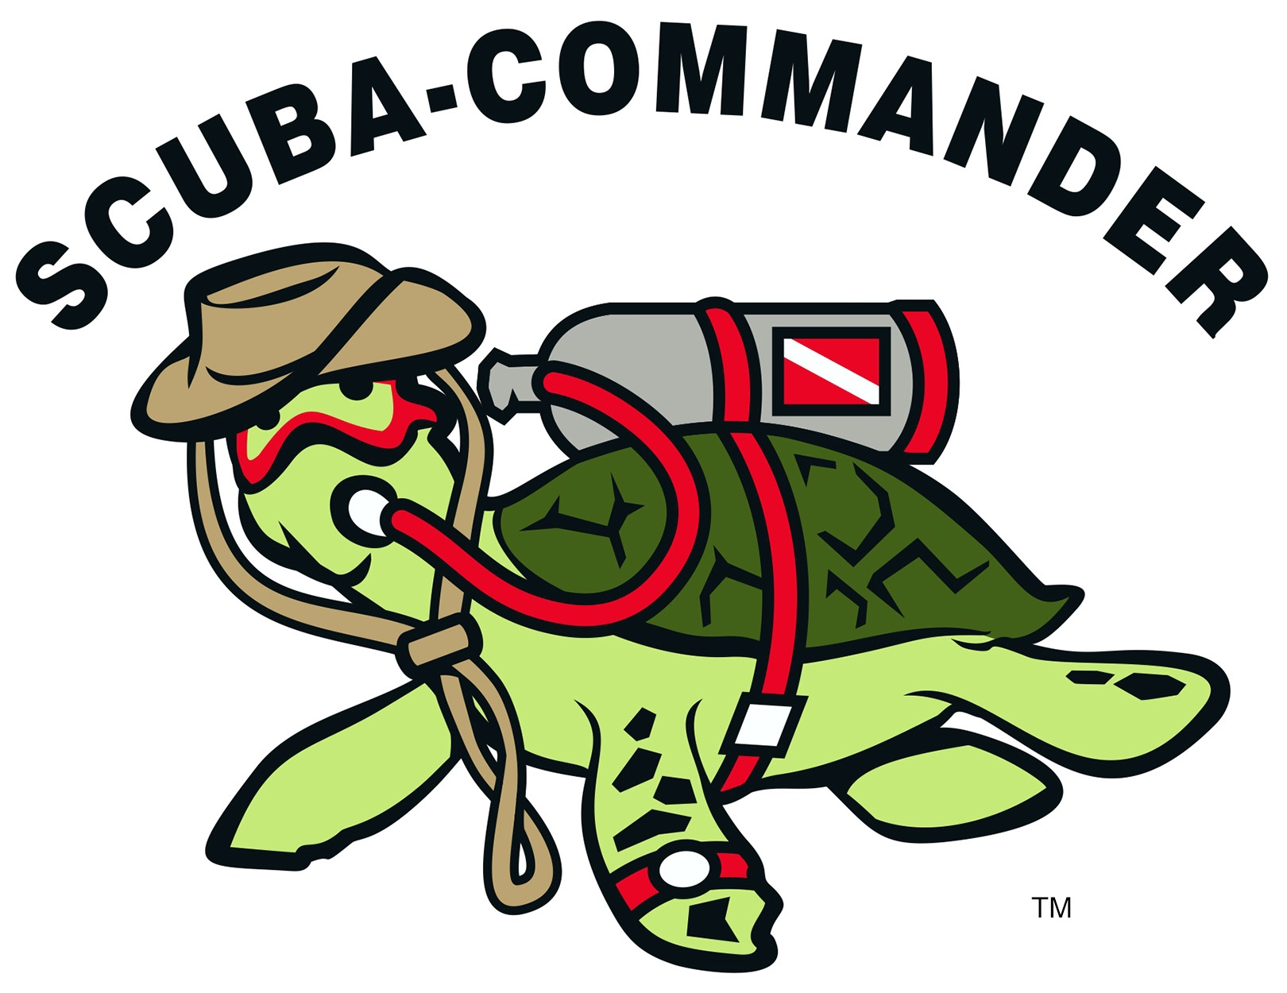

$75.99

**The Scuba Tune-up program is the perfect way to update your dive skills and knowledge from the PADI Open Water Diver Course before jumping back into the water.**

Whether you want a few reminders or need to go over the basics, this course is personalized for you: You conveniently review scuba concepts using our Scuba Tune-up Workbook then go diving with a PADI Professional in the pool. It’s quick and easy, and a good way to prepare for your next [PADI course](http://www.padi.com/scuba-diving/padi-courses/course-catalog/) or get ready for a [diving vacation](http://www.padi.com/scuba-diving/scuba-vacations/dive-travel/). Divers who complete both the knowledge and in-water skill refresher will get an updated sticker for their Open Water Card.

Any PADI certified diver who wants a refresher or pre-travel update should get a Scuba Tune-Up. Dive shops appreciate seeing a recent date on your certification card because it means you’re ready to dive in.

STUDENTS MUST PROVIDE:

All their own gear.

We will provide air tank.

Classroom and pool time is performance based, an estimate of 1.5 hr

# **GOING ON VACATION?** Haven’t been diving lately and want a quick scuba refresher?

### SCUBA-COMMANDER

123 N. BATTLEFIELD BLVD, SUITE B  
CHESAPEAKE, VA 23320

### Phone

757.547.0444

### Web

WWW.SCUBA-COMMANDER.COM