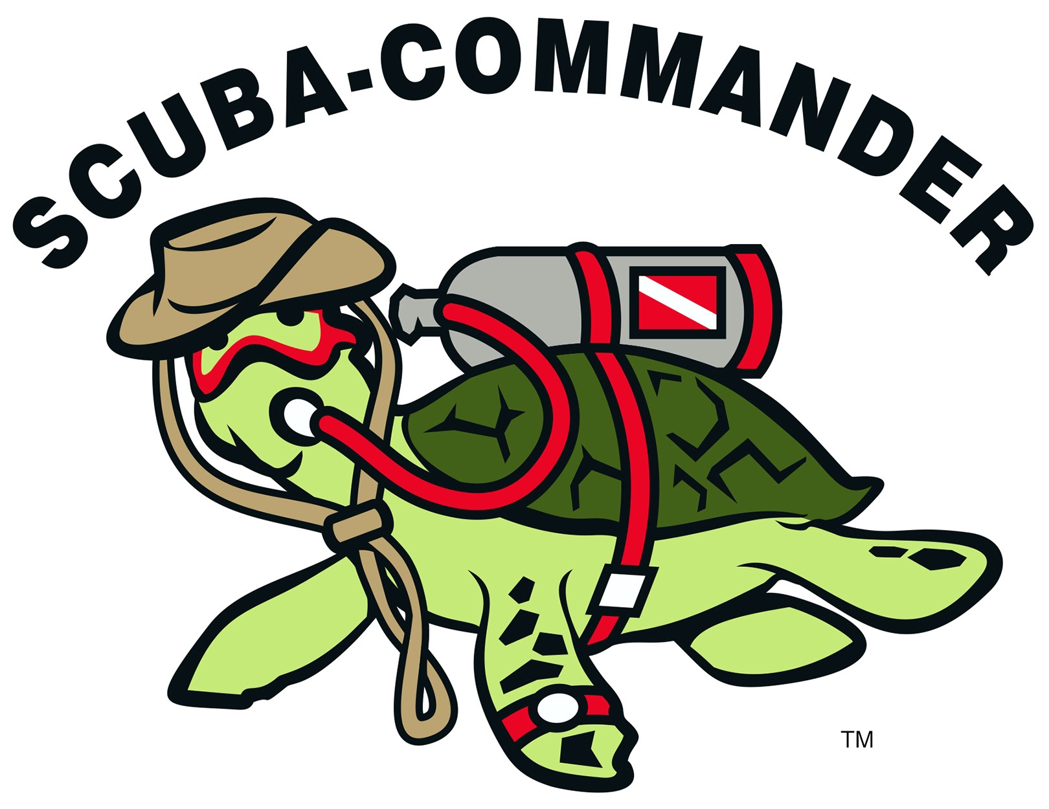

We offer this program in a confined pool area. While not a scuba certification course, Discover Scuba Diving is a quick and easy introduction to what it takes to explore the underwater world. To sign up for a Discover Scuba Diving experience, you must be at least 10 years old. No prior experience with scuba diving is necessary, but you need to be in reasonable physical health.

You learn the basic safety guidelines and skills needed to dive under the direct supervision of a PADI Professional.

**Get ready to:**

* Go over the [scuba equipment](http://www.padi.com/scuba-diving/padi-courses/course-catalog/about-scuba-gear/) you use to dive and how easy it is to move around underwater with your gear.
* Find out what it’s like to breathe underwater.
* Learn key skills that you’ll use during every scuba dive.
* Have fun swimming around and exploring.
* Hear about becoming a certified diver through the [PADI Open Water Diver course](http://www.padi.com/scuba-diving/PADI-Courses/Course-Catalog/PADI-Open-Water-Diver-Course/).

$99.99

STUDENTS MUST PROVIDE:

Swim suit and towel ☺

Classroom and pool time is an estimate of 2.0 hr

**\*\*\*\*Have you always wondered what it’s like to breathe underwater? If you want to try scuba diving, but aren’t quite ready to take the plunge into a certification course, Discover Scuba Diving is for you.**

### SCUBA-COMMANDER

123 N. BATTLEFIELD BLVD, SUITE B  
CHESAPEAKE, VA 23320

### Phone

757.547.0444

### Web

WWW.SCUBA-COMMANDER.COM