Wave Tucked Serger Pillow
Supply List
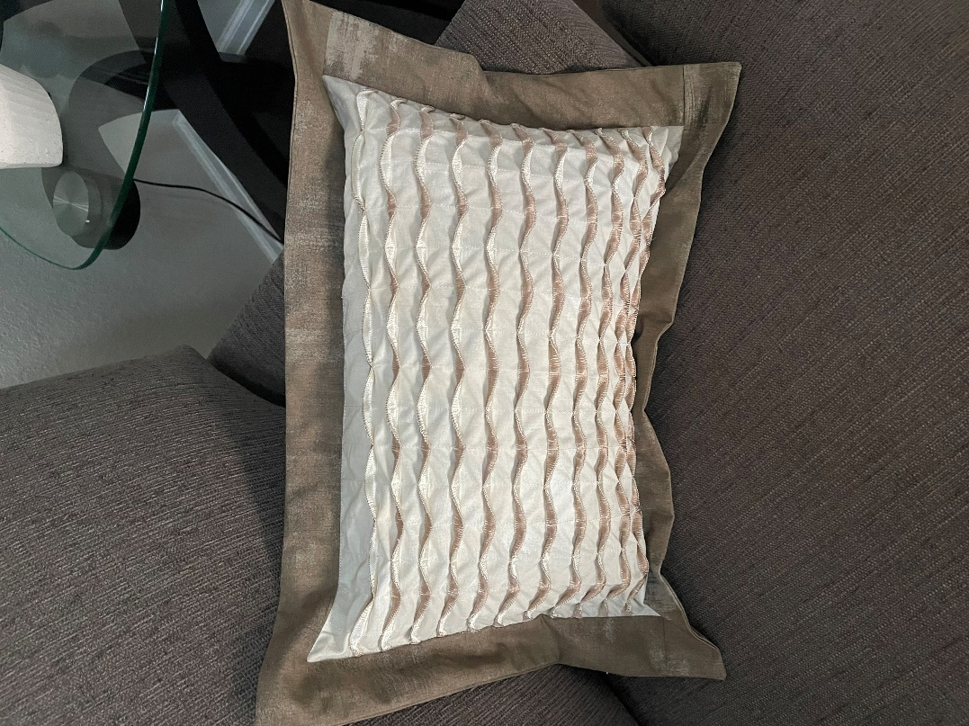

- Serger
- Kit available $11.99
- Clear foot (optional but very handy)
- ½ yard of base fabric – cut 18 x 20
- ½ yard of flange & backing fabric – cut (2) 2 ½ wof & (2) 12” x 16” (do not pre cut your backings)
- 3 spools of regular serger thread (I used cream)
- 1 spool of Madeira decora thread #1128
- 1 spool of Madeira décora thread #1071
- Ruler
- Frixion marking pen
- Regular sewing supplies

This project will incorporate a chain stitch section. If your serger does not do a chain stitch you will be able to use your regular sewing machine with cream colored thread.

