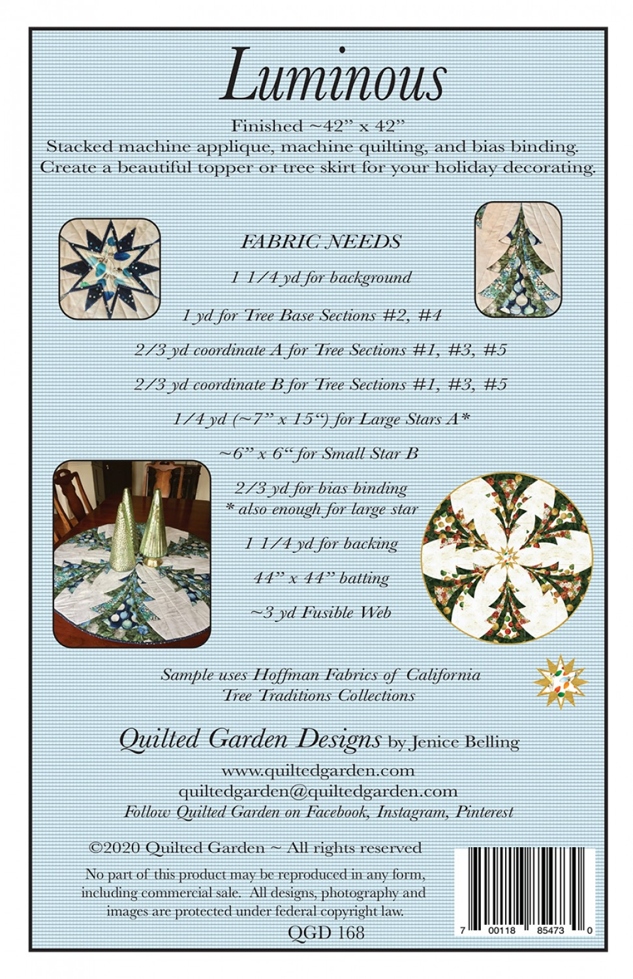
1 ¼ yards of background, backing and batting
1 yd for tree sections #2 and #4
2/3 yard of coordinate A for #1, #3 and #5
2/3 yard of coordinate B for #1, #3 and #5
¼ yard for Large Star A ( 7” x 15”)
6 x 6 for small star
2/3 yard for making bias binding
3 yd of fusible web (steam a seam lite or 2)
Thread for construction - thread for applique if using different
PATTER, scissors, ruler, sewing machine, marker.

I made templates for the trees and the stars prior to starting my project. Definitely helps make project move along quicker. Try to have those made prior to class..

