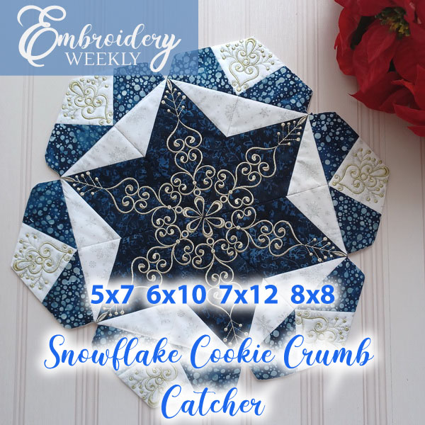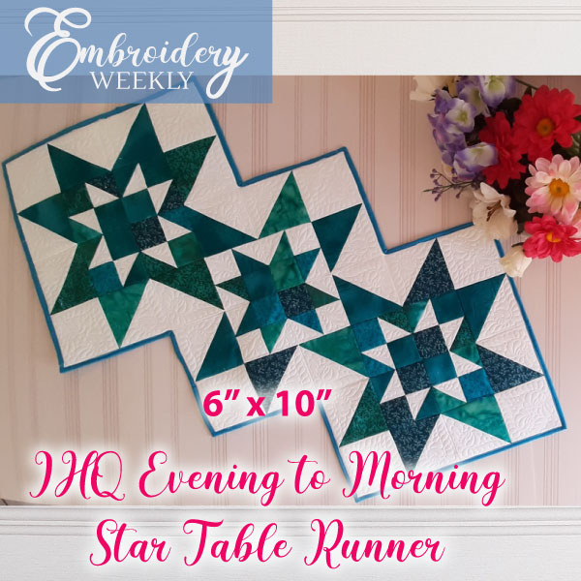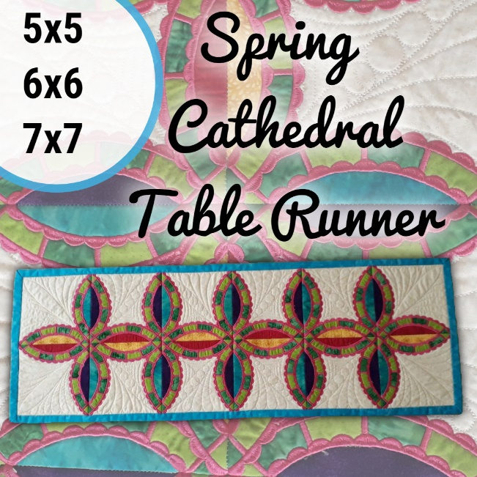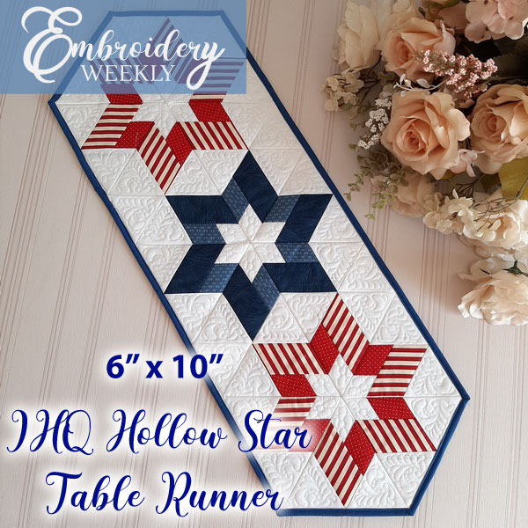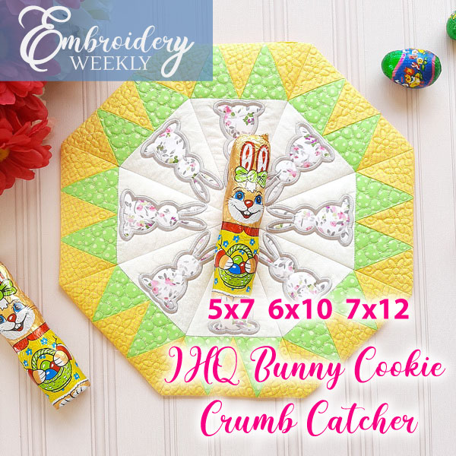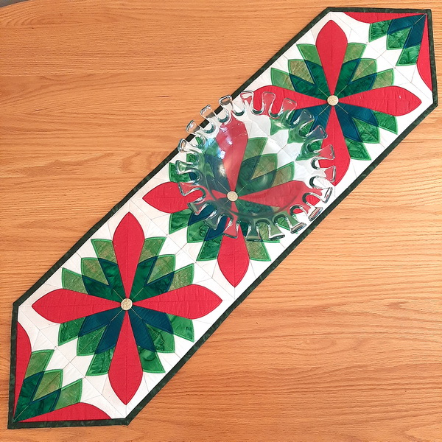
https://www.embweekly.co.za/designs/snowflake-cookie-crumb-catcher/

https://www.embweekly.co.za/designs/ihq-evening-to-morning-star-table-runner/

https://www.embweekly.co.za/designs/ew206-spring-cathedral-table-runner/

https://www.embweekly.co.za/designs/ihq-hollow-star-table-runner/

https://www.embweekly.co.za/designs/ihq-bunny-cookie-crumb-catcher/

https://www.embweekly.co.za/designs/christmas-fan-table-runner/

