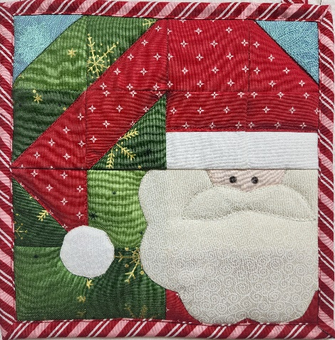
Santa Potholder
Class Dates:
Sunday, November 2, 12-3 or
Sunday, December 7, 12-3
Instructor: Julie Dess

Material needed:
Kit which includes supplies for 2 potholders

Supplies:
- Machine in good working order, clean with new needle, power cord, foot pedal
- Pins
- Add a ¼” ruler
- Omni Fold mat (ironing and cutting) 18 x 24 is nice size
- Small ruler, I like 2 1/2 “ x 12 ½” ruler,
- Rotary cutter
- Small travel iron
- ¼ inch foot
- Open toe foot for stitching beard
- extra needles for machine 80/20
- seam ripper, just in case

Prickly Pear Quilts
1200 Cedar Street
Helena, MT 59601
406-442-7327
CLASS POLICY

1. You can register in person, online, by mail or give us a call. Payment is required at the time of registering for class to secure your spot.
2. Prickly Pear Quilts would like to thank you for taking classes here. A 15% discount will be given on class supplies when you pay and register for class. This discount applies for this one class and will be given through the day off the class for class supplies.
3. Class registration allows one person to attend class.
4. Class supply lists are available on the PPQ website. When books, patterns, rulers and specialty items are required for the class, they must be purchased individually to prevent copyright violations.
5. All classes at PPQ (Prickly Pear Quilts) begin at the scheduled times. Please arrive 15 minutes prior to the class to set up for class so that the class can start on time.
6. Each class has a minimum student requirement. PPQ reserves the right to postpone or cancel a class due to not enough enrolled in the class. If PPQ must cancel, you will receive a full refund.
7. Due to contractual agreements with our educators, all payments for the class/events are NON-REFUNDABLE. However, payments are transferable to another attendee for the class/event. PPQ spends a great deal of time organizing and preparing for classes and events at PPQ. Class fees are non-refundable if you do not attend a class that PPQ did not cancel.
8. Please make sure that you have all the supplies on the supply list before the class starts.
9. Cell phones should be muted in class/events. Please put your cell phone on silent/vibrate while in class.
10. There is a refrigerator and microwave here if you would like to bring a snack, lunch, drinks, etc. Dinners Done Right is also in our strip mall and offers a full salad bar.

