Reversable Bowl Covers

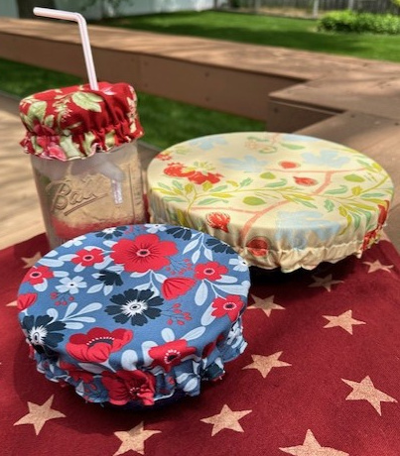

Cutting Instructions:
Tear off a piece of freezer paper at least 6” wider than width of bowl. On paper side of the freezer paper place the bowl right side down in the center. Using an Identi-pen, trace around the diameter of the bowl. Move bowl to the side. Use a small ruler and make hash marks 2” from drawn line all around bowl size.
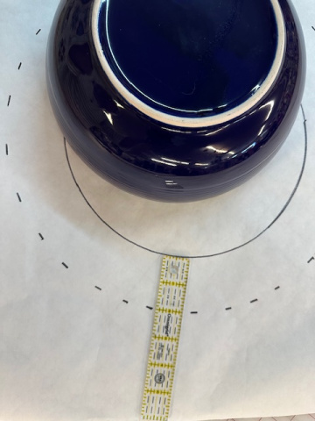
Take 2 fabrics of your choice and place right sides together. Iron the freezer paper pattern to the top of the fabrics. Cut around on the hash marked lines.
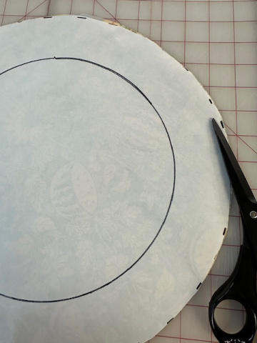

Separate the pieces and do a small zig zag around the outside edge of each fabric.
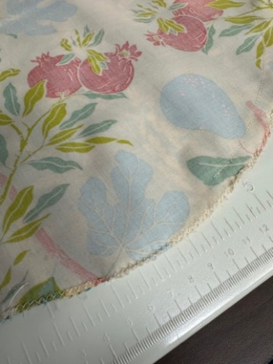
Place fabrics right side together. Sew two fabrics together using a small seam around the diameter. Leave a 2” wide opening to turn fabrics right side out.
Once turned right side out-press fabric seam even on both sides. Using different fabrics on each side gives a fun look for different occasions.
Next sew a casing stitch all around at ¾” from outside edge.
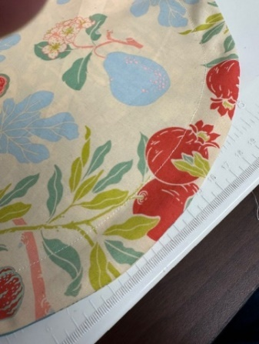
Cut a piece of ½” elastic approximate 2 times to width of your pattern.
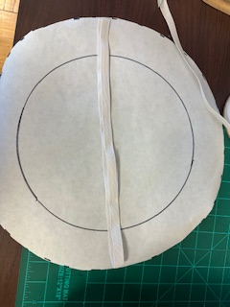
Use a bodkin to thread elastic through opening. Adjust elastic to size needed (don’t make to tight or cover will “creep” up)
Sew elastic ends together overlapping for security. Sew a line of stitching 1/8” from outside edge turning the edge of the opening inside even with sewn seam.
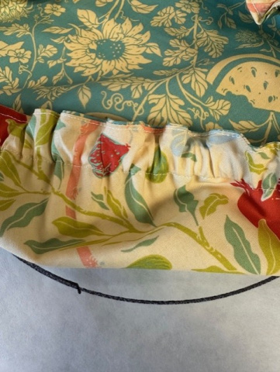

Now wasn’t that fun and easy! Make covers for all your bowls and be ready for picnics and pot lucks. This keeps the bugs out and makes the table settings look so pretty.

The covers also work good for other uses. Make one to fit your mason jar- add a buttonhole on top and you have a great drink cover. A great use also for sourdough starter while it is being feed-they like a bit of air to feed well.
Make a collection for all your serving bowls-the best decorating tip ever.

