Let’s Get Organized Class Supply List
Bernice Duffy July 21, 9:30-1:30
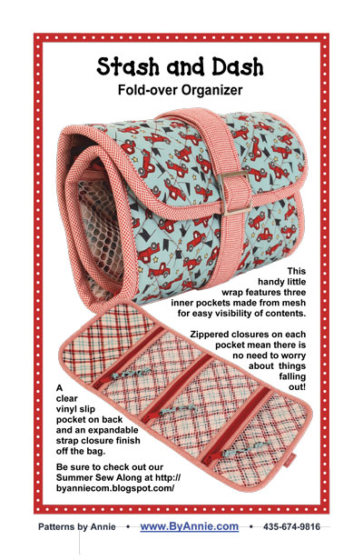
Pattern: Stash and Dash
Materials:
Fat quarter of main fabric
Fat Quarter of lining fabric
½ yard contrasting fabric
By Annie’s Soft and Stable 10” x 20”
Mesh fabric, clear vinyl, zippers, and slider in amounts
shown on pattern back
Thread

We will have some zipper-by-the-yard for your convenience if you choose to use it, with extra zipper pulls.
Supplies:
Sewing machine in good working order. Please be familiar with your machine.
Rotary cutting system (cutter, ruler, mat)
90/14 Microtex needle for machine
Please make any refund requests at least two days before class day. No refunds less than two days before.
Thank you
Zipper foot
Quarter inch foot
Other sewing supplies such as scissors, seam ripper, pins, etc.

You may also want a By Annie® Stiletto, Wonder Tape, and Wonder Clips. You will be shown these things in class. Materials and supplies are available at Prairie Point.
Pre-preparation:
Before coming to class, you must have your main fabric, lining, and Soft & Stable batting quilted. This may be done free-motion or straight line with your walking foot. Any type of simple design will be fine.
Prairie Point 913-268-3333

