Club
Resolve Your Stash

Cost of Club $200

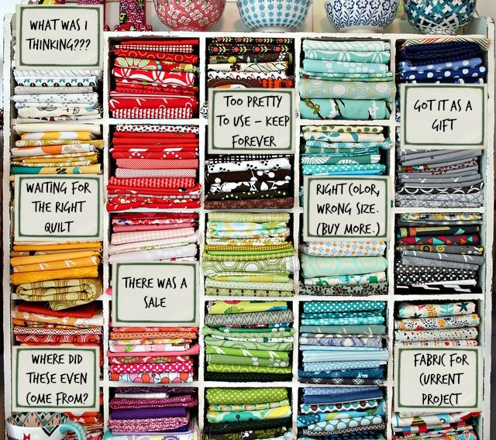
Dates January 22nd
February 19th
March 19th
April 16th
May 21st
June 18th
July 16th
August 20th
September 17th
October 15th
November 19th

Time 5:30 pm - 8:30 pm

Instructor Timothy

Description of Club

“Hello, my name is Timothy and I’m a fabric addict.” Come on, admit it - you are, too! This zealous group will take the first step in admitting they have a growing stash and that steps need to be taken to resolve it. Members will have 11 months to complete five required throw-size quilts (can easily be adjusted for larger sizes) and then have the opportunity to complete other optional stash projects using five patterns selected for them or using up those kits or bundles purchased in the past.

Members will receive a passport to keep track of their progress towards periodic rewards as well as a grand prize they will be working for. All the rules and regulations will be covered at our first meeting, so bring a friend who might also be a fabric addict - we know that a strong support system is the only way to a full recovery.

NOTE: Members will be encouraged to use ad much possible from their stash but understand that new fabrics can be purchased to achieve the desired look of their finished projects.

Club Objectives

Over the span of 11 months members will have the capacity to accomplish the following as a minimum:
- complete a minimum of five (5) require throw-size quilts (each can easily be adjusted to make it larger); and
- complete a minimum of five (5) optional projects.

Club Materials (Responsibility of Member)

The proper equipment will facilitate members in achieving the club objectives and reduce frustration [making your experience a more positive one].

The following is a list of suggested equipment to bring along to each club meeting:
- [Working] Sewing Machine with Manual
- Extra Bobbins, if desired
Please remind us to give you a 10% discount on all fabric and supplies for the class!
- specific to your machine
- Extra Sewing Machine Needles
- 80/12 are fairly standard
- Fabric, from your stash
- Thread
- Shears
- Small Scissors (clip thread with)
- Straight Pins
- Marking Pencil/Pen
- Flexible Tape Measure
- Seam Ripper
- Hand Sewing Needles (sharps)
- Rotary Cutter, optional
- Acrylic Ruler, optional

Additional Cost, if purchased at OJQ (before 10% discount)

“Postcard” Pattern Package
Required Pattern #1 $2.50
Required Pattern #2 $2.50
Required Pattern #3 $2.50
Required Pattern #4 $2.50
Required Pattern #5 $2.50

$12.50

