Reversable Strippy Table Runner
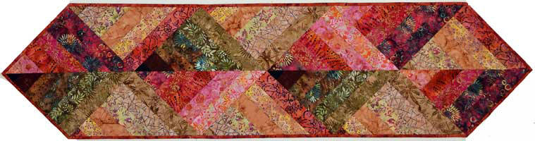
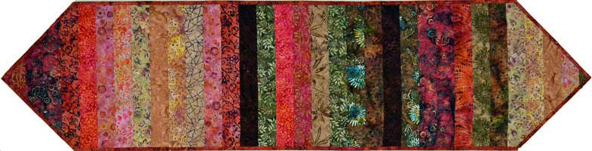

Grab a jelly roll and make this reversable table runner.
Class taught by: Terry Paulsen
Date: April 10, 2021
Time: 9:00 a.m. - 3:00 p.m.
Cost: $25.00
Class Materials
- Reversable Srippy Table Runner pattern by Plum Tree Quilts
- One jelly roll or 40 - 2 ½” strips
- 5/8th yard for binding and extra for side B
- 24” x 72” batting (suggested fusible batting or spray baste)
Basic sewing supplies:
- Sewing machine in good working order.
- Neutral colored thread with bobbin wound.
- 12 1/2 “or larger square ruler.
- Pins or clips, rotary cutter, seam ripper etc.
Prior to class:
