Tote It Vinyl Mesh Bag
Looking for something new in a tote bag? This bag (version A) incorporates colorful vinyl and your favorite fabrics to create a tote that is 20” wide and 13” high with pockets and a bottom support. ACME Fabric has several vinyl colors to choose from, and of course, lots of fabrics choices to create your unique bag.
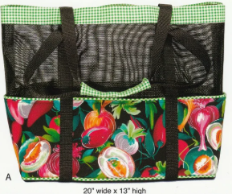
A

D
B
C

Supplies:
NOTE: Don’t trim off the selvages on your fabric.
- Vinyl- 5/8 yard by WOF
- Top Strip (A) – 3 ¾ Inches by WOF
- Bottom Strip (B) – 1/4 yard
- Lining (C) - 1/4 yard (coordinates with bottom strip B)
- Contrasting trim (D) 2” for top and 2” for bottom
- 1” Strapping – 3 yards
- Fusible fleece or thin batting ¼ yard by about 42”
- Bottom support: 6” by 15” corrugated cardboard, foam or other stiff material.
- Bottom Support Cover: 7” by WOF

Please bring to class:
- Sewing machine in good working condition
- ¼ inch foot for your sewing machine
- Basic sewing kit – pins, small scissors, seam ripper, thread, etc.
- Rotary cutter with a sharp blade, rulers and cutting mat.
- Small iron and ironing mat.

Class is March 12, 2026; 9:30-3:30

