Stripology Class – Ana & Elsa
Required Supply List:
- Stripology ruler – Squared or XL
- Stripology Quickies Pattern book
- GEasy Ruler Stickers
- Select your desired quilt size and bring fabrics required. Please do not cut your fabric before class.
- Rotary cutter (with new blade) and cutting mat large enough for your Stripology ruler
- Highlighter
- Sewing machine in good working condition
- ¼” foot
- Basic sewing supplies – pins, small scissors, seam ripper, thread, stiletto
- Small iron and ironing mat

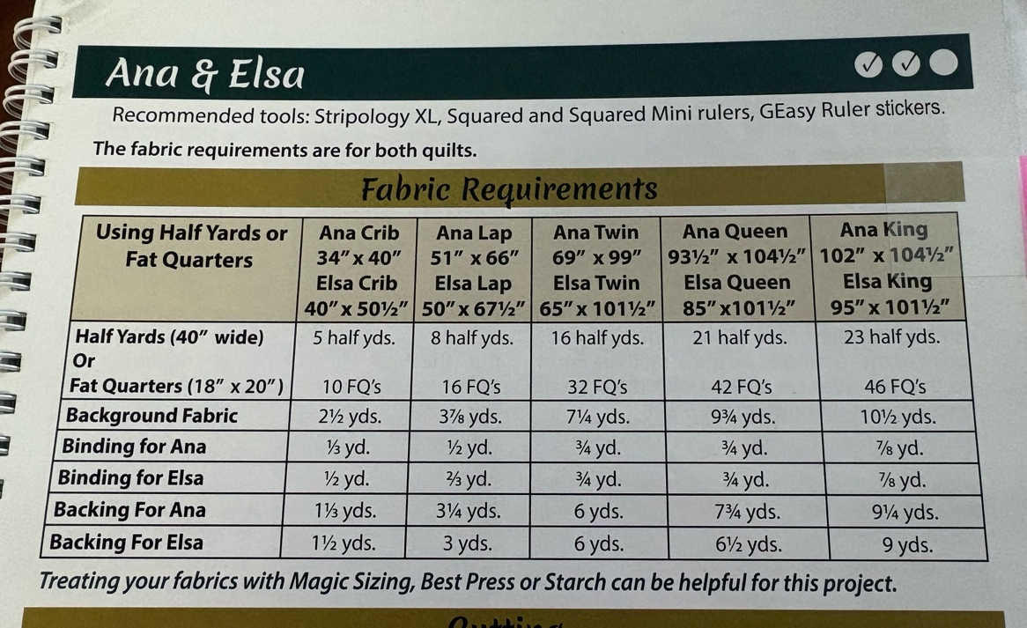
If you have any questions prior to class, please contact Barb Townley 402-707-0860.

