Mod Owl Revival Quilt

Required supplies:
- Mod Owl Revival Quilt
- Quick Curve Ruler, Mini Quick Curve Ruler
- Your favorite ruler if trimming flying geese. I will be demonstrating my favorite using Wing Clipper

Please do not precut your fabric before class. We will cut

There is a kit available for purchase at ACME, or you are welcome to bring your own fabric. If using your own fabric you will need fabric as listed below.

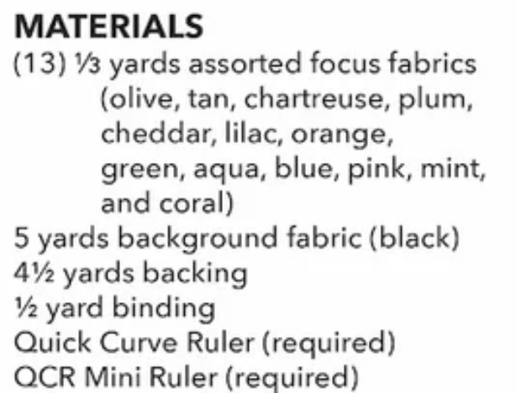

Please bring the following basic supplies to class:
- Sewing machine in good working condition
- ¼” foot
- Stilletto
- Basic sewing supplies - pins, small scissors, seam ripper, thread…
- Favorite ruler for squaring up (6”x12”, 6”x6”…)
- Small iron and ironing surface (ACME has some in the classroom but will be convenient to have one at your sewing space
- small cutting mat and rotary cutter - this will also be more convenient to have one at your sewing space

If you have any questions prior to class please contact Theresa Winter 402-980-4077

