Mia Stripology Class
Required Supplies:
- Stripology Squared or XL Ruler
- Stripology Quickies pattern book
- Optional – Geasy Ruler Stickers
- Fabric based on the quilt size you will be making – do not cut fabric before class

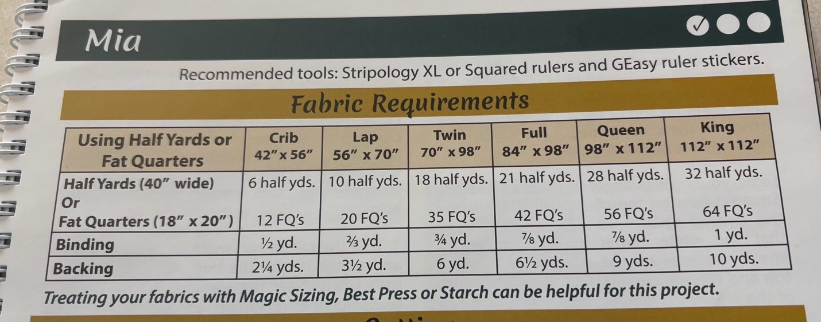

Please do not precut your fabric before class. You will be learning how to use the Stripology Ruler for quick and accurate cutting from yardage to strips, squares and rectangles, etc. You will also learn how to square up blocks up to 12.5 inches.
Please bring the following basic supplies to class:
- Sewing machine in good working condition
- ¼ “ foot
- Basic sewing supplies – pins, small scissors, seam ripper, thread, stiletto
- Small iron and ironing surface (ACME has some in the classroom, but it will be convenient to have one at your sewing space.
- Rotary cutter and cutting mat large enough for your Stripology ruler. Again, there are some in the classroom, but it might be more convenient if you have one at your space.

You might want to bring a sack lunch; we will be working over the lunch hour.
Have some fun with the blocks and try some different layouts!

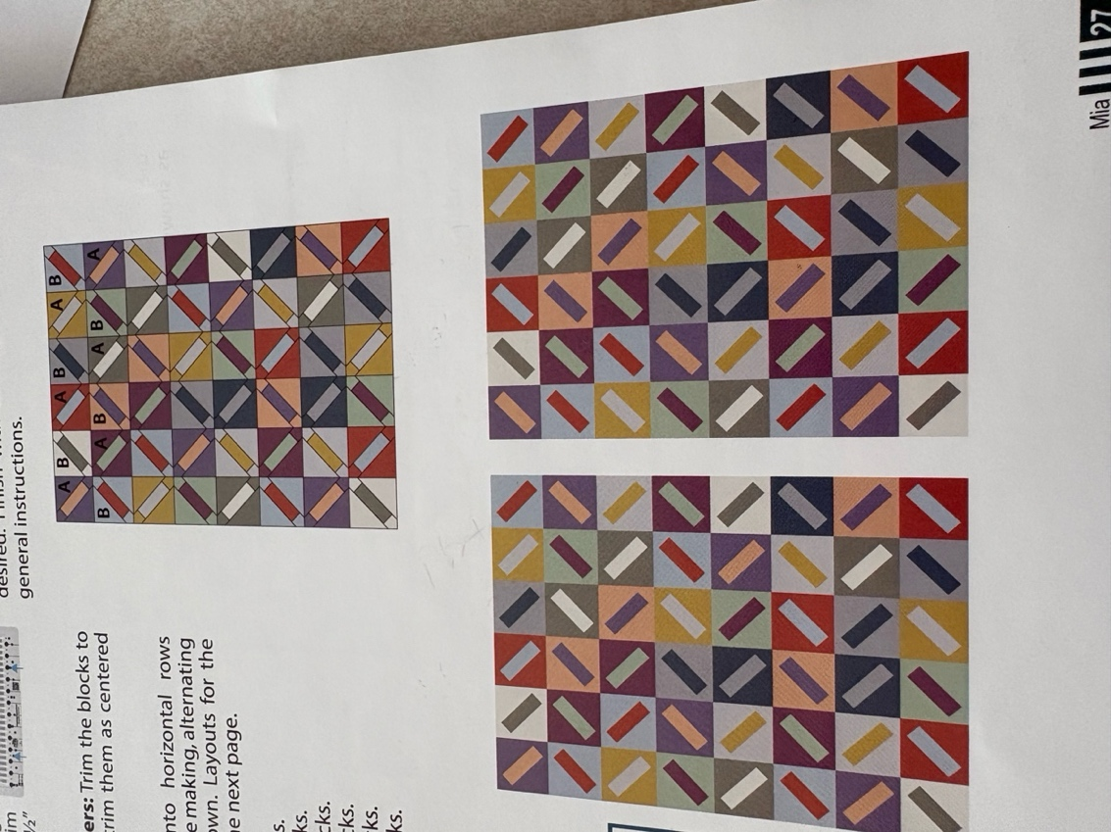

If you have any questions prior to class, please contact Barb Townley 402-707-0860.

I look forward to spending the day with you!
Barb

