Foundation Paper Piecing
Have you ever wanted to give foundation paper piecing (FPP) a try? FPP allows you to sew precise, intricate designs by stitching fabric to a paper foundation. In this introductory class we will cover the basics on FPP and create a block that is a variation on the Lone Star.
Background Fabric: one fat quarter; this fabric should be a high contrast color to your inner points
Inner points: you can use one color (fat quarter) or multiple colors (fat eights of each).
Outer points: fat eights of each color.

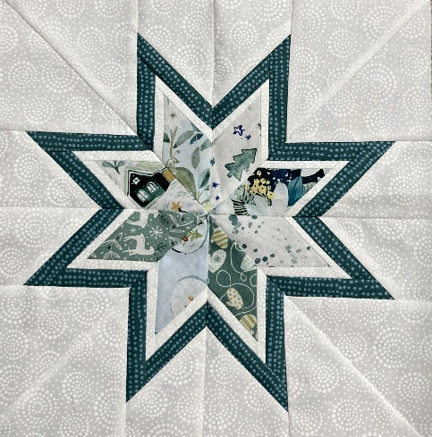
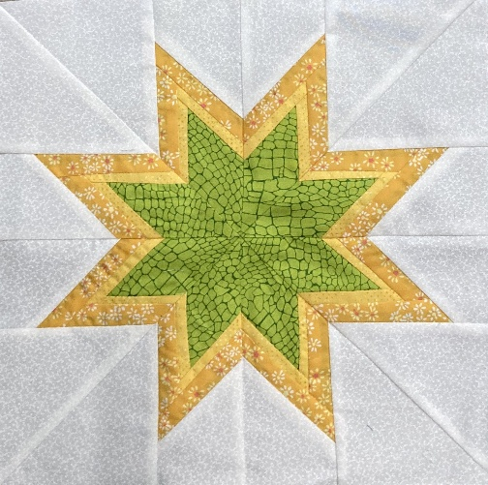

Please bring to class:
- Sewing machine in good working condition
- ¼ inch foot for your sewing machine
- Basic sewing kit – pins, small scissors, seam ripper, thread, etc.
- Rotary cutter with a sharp blade, rulers and cutting mat.
- Repositionable glue stick
- Small iron and ironing mat

Class is February 12, 2026, 9:30-12:30

