Custom Kicks with Kate
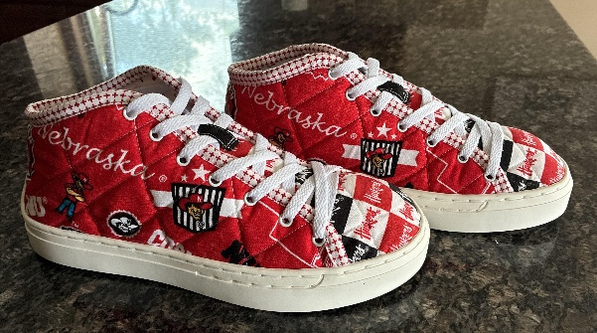
With quilted sneaker soles and kits, you can turn your favorite fabrics, quilting patterns, and embroidery into creativity for your feet.
Join Kate as she guides you through the process of creating your very own unique sneakers.

PURCHASE: Patchwork Kicks Kit, includes the following items. All you need to add are your favorite fabrics as noted on the kit instruction sheet.
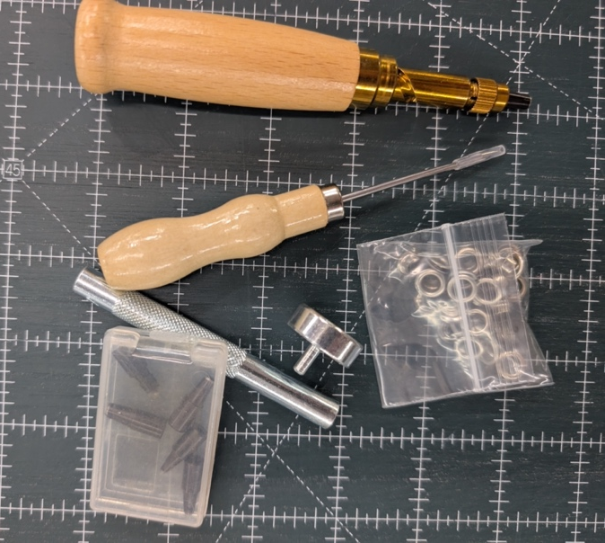
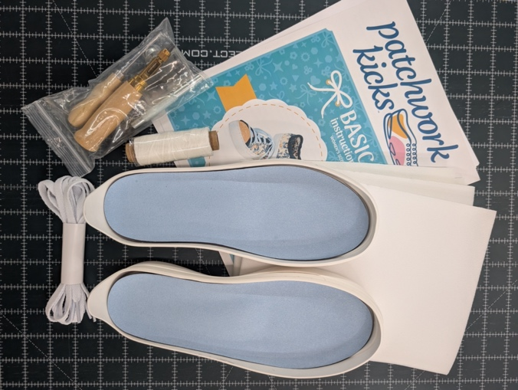

CLASS SCHEDULE
August 1st 9:30 – Noon; introduction to the sneaker kit, fabric ideas, quilting suggestion etc. Pattern cutting will be discussed as the fabric choice(s) dictate how the pattern will need to be cut. Our time on this day will also include Kate and the ACME staff assisting you while you shop for the perfect fabric(s) for your truly unique sneakers. If you have fabric in mind for your project, please bring that. Please do not bring a sewing machine as our time will be discussion and shopping. You will have a few days to prepare your fabric for class on August 4th.

August 4th 9:30-3:00; on this day, we will start the pattern cutting and assembly; adding the interfacing, lining, binding and grommets.

August 5th 9:30-3:00; today will be all about stitching your sides and tongue onto the soles.

Supply List (Needed for August 4th and 5th:
- Sewing machine in good working order (not needed on August 1st)
- Patchwork Kicks kit
- Fabric as listed on pattern. We will be discussing fabric options and different design options on Day 1. You can wait to purchase fabric until day 1 of class if you want to consider different options.
- Thread to match your project, you may need more than one color for binding and embellishments. We will use cotton Thread (50 WT)
- Bobbins
- Size 12 or 14 sewing machine needles
- Walking foot
- ¼” foot and a zipper foot might be helpful when sewing on binding
- scissors
- cutting mat, rotary cutter and 24” ruler
- fabric marking pencil
- wonder clips (variety of sizes is helpful)
- stiletto
- basting tape, glue stick, etc. (optional, but helpful)

