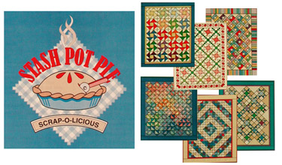Stash Pot Pie Month Two

Class Supply Sheet

This quilt uses scraps for the background as well as the stars! Don’t overlook using background scraps with some color to them. Like pale pinks, blue, tans or greys.

Whatever you choose, make sure the fabrics for your stars contrast well. **You must have all the cutting done before class!** We don’t have time to cut because we will be sewing, sewing, sewing!! There is no pattern needed, you will get your free pattern and recipe when you show up for class!

We will be making a small quilt, 38 ¼ ” X 51”. You also have the option to add a border to make it bigger. 46 ½” X 59 ¼”

Fabric Requirements: Cutting Instructions before class:

1 yard assorted dark fabrics for stars From assorted dark fabric cut:

2 ¼ yards assorted light fabrics for background 18- 3 ½” squares & 36- 4 ¼” squares

¼ yard inner border From assorted light fabrics cut:

¾ yard outer border 72 – 3 ½” squares

½ yard binding 36- 4 ½” squares

2 ¾ yards backing 3 – 14” squares cut in half twice

2- 7 ¼” squares cut in half once 

Other supplies needed:

Make sure you have your sewing machine in good working order and you know how to use it.

Rotary cutter and ruler, scissors, seam ripper, pins, frixion pen, quick quarter seam guide,etc

Neutral thread and some pre-wound bobbins.

We can take a short break for lunch or you can pack your own bag lunch and keep on sewing. It’s a good idea to bring a snack and drink. We have a long day of sewing ahead of us, to get these scraps made into something beautiful!! Can’t wait to see you!

Class Date: ___________________________________________

Class Time: ___________________________________________