Judy Niemeyer Foundation Piecing Supply List
Supplies:
✓ Twinkle Star Pattern
✓ Fabric Requirements (see pattern) or purchase prepared kit
- If selecting own fabrics you will need 2 dark, 2 light, and 4 medium pieces (see picture
below for sample selections)
✓ 12 inch Add-A-Quarter Ruler
✓ Flower pins
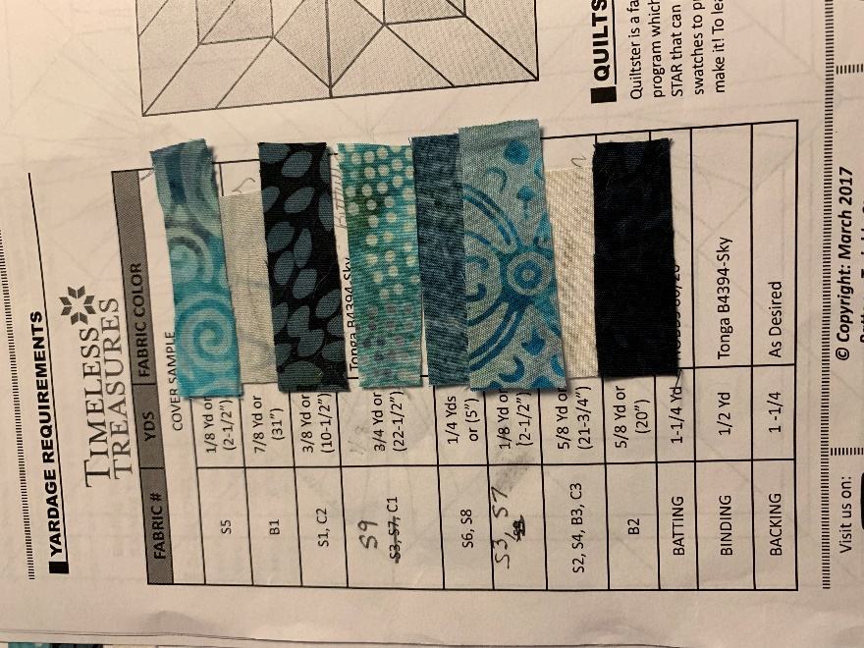
✓ Fabric glue stick or glue pin (water washout)
✓ Purple Thang or stiletto that does not poke through fabric
✓ Large Ziploc bags (8)
✓ Scotch tape
✓ Wonder clips, binder or paper clips

General Sewing Supplies:
✓ Sewing Machine
✓ 6x24 inch ruler
✓ Rotary cutter
✓ Small scissors
✓ Seam ripper
✓ Size 70 (10) sewing needle
✓ High-quality thread
✓ 1/4 inch foot

Homework prior to class:
✓ Read through the General Instruction section of the pattern (pages 1-4)
✓ Prepare the Foundation Papers (page 2)
✓ Have fabric swatches placed on the last page (16) of instructions as pictured

Class Date:_____________________________________________
Class Time:_____________________________________________

