HanD APPLIQUÉ
  - Learn tips and tricks to master
  - the art of hand appliqué

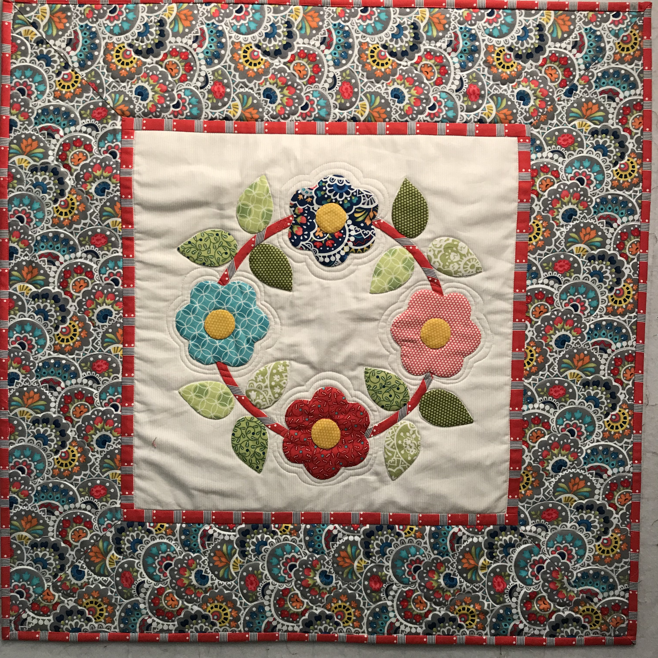

Supply list

- Book “Needleturn Applique: The Basics and Beyond”
by Angela Lawrence
- Appliqué pins
- Roxanne’s glue – Dab It or small bottle)
- Appliqué or Straw needles – size 10 or 11
- Thread to match fabric choices
- Freezer paper
- Frixion pen
- Thimble
- One 18 inch square or Fat Quarter background piece
- Fabric scraps for stem (will be cut on bias), leaves, flowers
- Clover bias maker 9mm

Optional
- Perfect Circles
- Sand board
- Needle threader
- Dressmaker tracing wheel

