Fabric Yardage
Black Solid | 3½ yd.
Sky Print | 1⅛ yd.
Green | ⅝ yd.
Orange Floral | ¼ yd.
Red Floral | ⅜ yd.
Yellow Floral | ¼ yd.
Leaf Print | ¼ yd.
Backing | 3½ yd.

Notions:
Thread for piecing, applique, and quilting.
3 yards of Steam-A-Seam 2 for fusible appliqué.

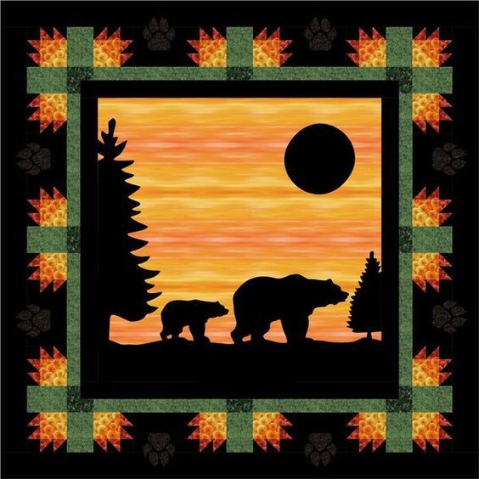
Evening Stroll
Finished Size: 54 in. x 54 in.
Originally Designed by: Christine Stainbrook

Cutting Instructions
Black Solid:
3 – 2⅜ in. x WOF, subcut every 2⅜ in. to yield 40 – 2⅜ in. squares
2 – 2 in. x WOF, subcut every 2 in. to yield 20 – 2 in. squares
1 – 6½ in. x WOF, subcut every 5 in. to yield 8 – 5 in. x 6½ in. rectangles
4 – 2½ in. x WOF strips.
6 – 3½ in. x WOF strips
Remaining yardage is for appliqués and binding.
Green:
4 – 2 in. x WOF, subcut every 15½ in. to yield 8 – 15½ in. x 2 in. strips
1 – 5 in. x WOF, subcut every 3½ in. to yield 12 – 5 in. x 3½ in. rectangles
Leaf Print:
1 – 2 in. x WOF, subcut every 3½ in. to yield 8 – 2 in. x 3½ in. rectangles
1 – 2 in. x WOF, subcut every 2 in. to yield 4 – 2 in. squares
Sky Print:
1 – 32½ in. square
Red Floral:
3 – 2⅜ in. x WOF, subcut every 2⅜ in. to yield 40 – 2⅜ in. squares
Yellow Floral:
1 – 3⅞ in. x WOF, subcut every 3⅞ in. to yield 10 – 3⅞ in. squares
Orange Floral:
1 – 3⅞ in. x WOF, subcut every 3⅞ in. to yield 10 – 3⅞ in. squares

Appliqué Instructions (for center block)
Trace patterns for bears, trees, moon and ground onto the grid side of the Steam-A-Seam 2 (NOTE: patterns need to be traced in reverse.). Cut out patterns leaving about ⅛ in. margin around each pattern. Remove the plain backing from the Steam-A-Seam 2 and place it on the wrong side of the black fabric. Press in place with a DRY iron and let cool. Cut out the patterns on the traced lines. Remove the grid paper from the patterns and place the patterns onto the Sky fabric. To permanently fuse the black fabric to the sky fabric, press with steam for 15 seconds – the steam sets the glue, so don’t skimp. Stitch down the edges of the appliqué using a blanket stitch or straight stitch.

Piecing Instructions
All seams are sewn with a ¼ in. seam allowance.
Bear Paw Blocks
Draw a diagonal line on wrong side of the red floral 2⅜ in. squares. Pair with the black solid 2⅜ in. squares and stitch a ¼ in. seam on each side of the drawn line. Cut on the drawn line and press the seam of two half-square triangle units toward the black fabric. Trim units to 2 in. square if necessary. Make 80 half-square triangle units.
Repeat with the orange floral and yellow floral 3⅞ in. squares, trimming to 3½ in. square if necessary. Make 20 half-square triangle units.
Combine 1 orange/yellow half-square triangle unit with 1 black 2 in. square and 4 red/black half-square triangle units. Please note that two of these black/red units go in one direction and the other in the reverse (see below image).
Trim the assembled block to 5 in. square if needed. Repeat to make 20 blocks total.
Inner Pieced Border
Sides:
Take 2 leaf print 2 in. squares, 1 leaf print 2 in. x 3½ in. rectangle, and 2 green 15½ in. strips and sew together lengthwise as shown:
Repeat to make 2 side inner pieced borders.
Top and Bottom:
Take 3 leaf print 2 in. x 3½ in. rectangles and 2 green 15½ in. strips and sew together lengthwise as shown:
Repeat to make the top and bottom inner pieced borders.
Outer Pieced Border
Sides:
Take 4 bear paw blocks, 3 green 5 in. x 3½ in. rectangles, and 2 black 5 in. x 6½ in. rectangles and sew together lengthwise as shown:
Be sure to note the positioning of the bear paw blocks. Repeat to make the side outer pieced borders.
Top and Bottom:
Take 6 bear paw blocks, 3 green 5 in. x 3½ in. rectangles, and 2 black 5 in. x 6½ in. rectangles and sew as shown:
Be sure to note the positioning of the bear paw blocks. Repeat to make the top and bottom outer pieced borders.
Assembly
With the appliqué block as your quilt center, you will add four borders to frame the center:
1st Border
Take 2 of the black 2½ in x WOF strips and trim each strip to 32½ in. Sew these to the sides of the quilt center. Press the seam toward the border. Then take the other 2 black 2½ in. x WOF strips and trim each strip to 36½ in. Sew these strips to the top and bottom of the quilt center. Press seams toward the borders.
2nd Border
Take the 2 side Inner Pieced Borders, sew them to the sides of the quilt center and press towards the outer borders. Now take the other 2 Inner Pieced Borders, sew them to the top and bottom of the quilt center and press towards the outer borders.
3rd Border
Take the 2 side Outer Pieced Borders, pin them to the sides of the quilt center making sure to match up seams from the inner border, sew in place, and press towards outer border. With the remaining Outer Pieced Borders, pin them to the top and bottom of the quilt center (pinning to match up any seams), sew in place, and press towards outer border.
4th Border
Measure the length of your assembled quilt through the center to get the side dimensions (approximately 48½ in.) for your side borders. Take 3 of the black 3½ in. x WOF strips and sew them together to get one long strip. Cut two side border strips the measured length from this long strip. Pin these strips to the sides of your quilt, sew in place, and press the seams towards this outer border.
Now, measure width of your quilt through the center to get the measurement for the top and bottom strips. Sew the other 3 black 3½ in. x WOF strips together and then then cut the top and bottom border strips from that strip. Pin to the top and bottom of your quilt, sew in place, and press seams towards the outer border.
Layer, baste, and quilt as desired. Bind with the remaining black fabric.

