The Flow and Grow Story
My name is Jack Brown, and I am the originator of WaterBoy Sports, Inc., a company with 30 years of experience in manufacturing and distributing patented hydration equipment for the athletic industry. For three decades, WaterBoy Sports has successfully supplied hydration systems to professional, collegiate, high school, and youth league teams, meeting their hydration needs with innovative solutions.
In 2013, I sold WaterBoy Sports and embarked on a new journey: designing a water delivery system that not only hydrates but also fertilizes living plants. Thus, Flow and Grow was born, aimed at providing efficient watering systems to professional indoor plant maintenance companies, primarily for office environments.
However, the onset of the COVID-19 pandemic drastically shifted our target market. After extensive research and reflection on my experiences, I realized that there was a significant opportunity to pivot our focus. Flow and Grow is now prepared to introduce a revolutionary hydration unit that will seamlessly hydrate and fertilize potted plants in retail environments.
Our newly conceived hydration unit will enable retailers to strategically place seasonal, healthy plants anywhere in a store—be it at check-out counters or entrances—enhancing visual appeal and attracting impulse and last-minute purchases. The “FLOW and GROWER” stands ready to provide stronger, healthier and more visually appealing “Living Goods” for customer satisfaction.
By reducing product loss and minimizing the risk of slippery and dangerous floors, our system not only enhances the customers’ shopping experience but also promotes responsible plant care and maintenance. With Flow and Grow, retailers can elevate their environment, increase sales, and ensure that every plant thrives, all while creating a safer and more inviting atmosphere for their customers.
Join us as we cultivate a greener future, where every plant flourishes and every retail space becomes a vibrant testament to the beauty of nature!
—Update-I have recently re-partnered with my original company WaterBoy Sports, now Waterboy Sports, LLC, to manufacture and distribute the newly announced “FLOW and GROWER” to service the starving plants and flowers in retail outlets everywhere. The company has manufactured, distributed and serviced thousands of high-quality and patented hydration units to the athletic industry for years. Their history of innovation, quality and service is well-documented and will ensure excellent products being delivered to your facility in a timely manner.
Be assured the FLOW and GROWER unit has been thoroughly tested in actual retail garden centers and is prepared to function upon delivery with user-friendly operation and easy maintenance. Our dedicated service team is available 24 hours a day to answer any questions, be they sales, service, shipping or operational in nature.
Jack Brown

Waterboy Sports 23-gallon Athletic Team Hydration unit
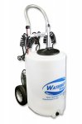

Flow and GrowER 23-gallon Garden Center Plant and Foliage Feeding and Watering Unit
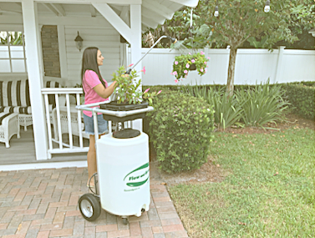

Flow and GrowER 50-gallon Garden Center Plant and Foliage Feeding and Watering Unit
