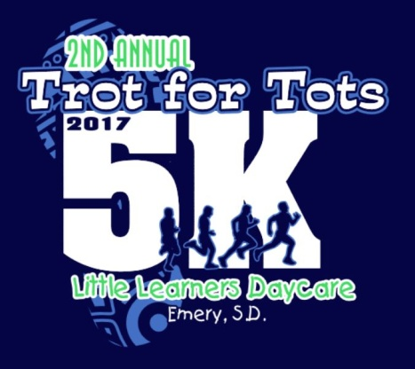
Little Learner’s
5k Trot for Tots Run/Walk
June 10th, 2017
8am registration/8:30 Start Time

Race Information: Pre-Register for the 5K by June 2nd for a free t-shirt!
$20 for adults; $15 for students – all proceeds to benefit Little Learners Preschool and Daycare. Registration available the day of the race starting at 8:00am. Water, juice, and bananas will be available for the runners after the race. We will run rain or shine, so please dress according for the weather!

Course Description: 5K run/walk starting at Little Learners (160 N 3rd St) and ending at the Emery City Park – by the baseball fields and swimming pool. Children are welcome and encouraged to participate. The route will wind its way through the town of Emery staying on the North side of Hwy 262 (trying to avoid streets that are under construction!).

Additional Information: Race starts at 8:30am! 605-449-4111 OR 605-449-4455; www.cityofemerysd.com; littlelearners@triotel.net; emerycity@triotel.net
____________________________________________________________________

Mail Entry Form and make Checks payable to:
Little Learners, 160 N 3rd St, PO Box 304, Emery, SD 57332

NAME: ____________________________ DOB: _____ PHONE: _________________

ADDRESS: ___________________ CITY: ______________ STATE: ____ ZIP_______

EMAIL: ___________________ T-SHIRT SIZE: ___________________

Check one ADULT: _____ STUDENT: ______

WAIVER: I know that running a road race is a potentially hazardous activity. I should not enter unless I am medically able and properly trained. I assume all risks associated with running this event. Having read this waiver and knowing these facts and in consideration of your accepting my entry fee, I, for myself, and anyone entitled to act on my behalf, waive and release Little Learner’s, City of Emery, and all sponsors, their representatives and successors, for all claims or liabilities of any kind arising out of my participation in this event.

________________________________________ ____________________________
Signature (Parent’s Signature If under 18) Date

