QUILT ALONG – WEEK 6

This our last week. We hope that you have had fun and learned some new techniques.

All seam allowances are ¼”.

MONKEY WRENCH – this block is similar to Snail’s Trail, but with one less round.
You need two fabrics, a background and a color. 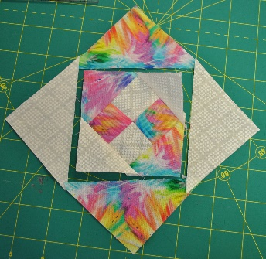

From the background:

A – (1) 4 ¼” x 4 ¼” square cut in half diagonally
C - (1) 4 ½” x 4 ½” square cut diagonally both ways = 4 small triangles
E- (1) 2 ½” x 2 ½” square cut in half diagonally
G -(2) 1 ½” x 1 ½” square

From the color:
B - (1) 4” x 4” square, cut in half diagonally
D – (1) 4 ½” x 4 ½” square cut diagonally both ways = 4 small triangles
F – (1) 2 ½” x 2 ½” square cut in half diagonally
H – (2) 1 ½” x 1 ½” squares

- Starting with the 1 ½”x 1 ½” squares in both the background and color G & H, make a four patch. I put the “color” in the upper left corner…more on that later. 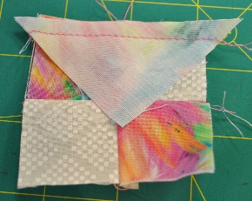

- Now add the “color” triangles from the 2 ½” x 2 ½” square cut diagonally (E) , as well as the background color triangles from the same size block (F) adding the color to the top and bottom and the background triangles to both sides. Be sure to center the triangles on each side. Open and press carefully. You are working with bias edges.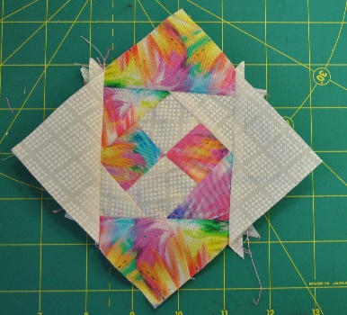

Which triangle goes where? Look at the color on the top left side of the patch. If it’s a color, then the triangle at the top and bottom will be a color. (and vice versa).

- The next round is the same as #2 except use triangles Cand D. Again, what color is the upper left corner? That’s the color triangle for the top and bottom. 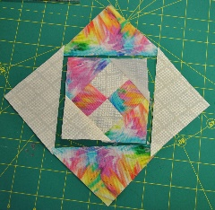

- The last round is the same as #2 except use triangles A and B. What color is the upper left corner? That’s the color triangle for the top and bottom.

Carefully press. The block will be slightly oversized, trim to 6 ½” x 6 ½”.

CAT’S CRADLE – this block has many pieces, take your time and you will do fine.
You need two fabrics: a background and a color. 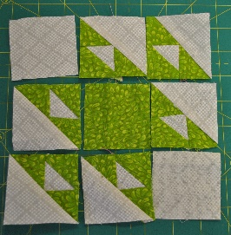

Background: Cut
A – (2) 2 ½” x 2 ½” square
C – (3) 2 ¼” x 2 ¼” squares cut in half diagonally = 6 triangles
D – (3) 3 ¼” x 3 ¼” squares cut in half diagonally = 6 triangles

Color: Cut
B – (9) 2” x 2” squares cut in half diagonally -= 18 little triangles
E – (1) 2 ½” x 2 ½” square

- Using 3 little triangles (B) and one C triangle, make the following set:
Sew a color B triangle to a background C triangle to make a half square triangle (HST). Press carefully.
Add a little B triangle to each side of the HST, lining up the color triangles to the sides of the little white triangle. Do you see how the green triangles make a straight line?

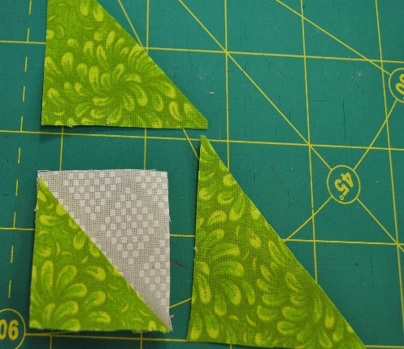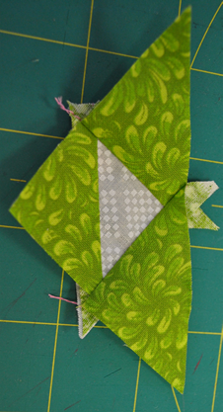

2. To the little triangles unit, add a background D triangle. You should have 6 units.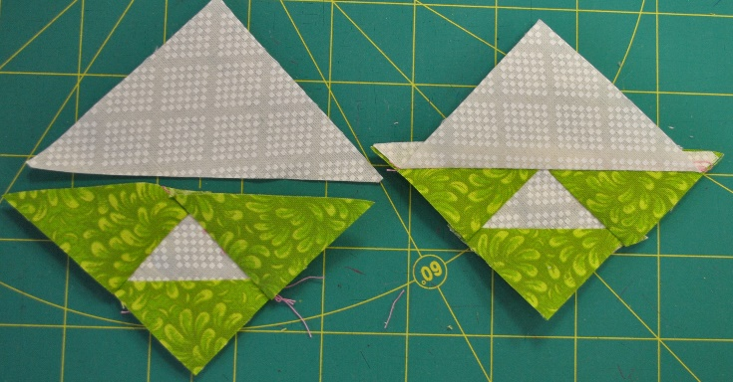

3. Construct the block like a 9 patch:
1st row – Background A square, Little triangle unit, little triangle unit.
Pay attention to the orientation of the larger background triangle.
2nd row - Little triangle unit, color square E, little triangle unit.
3rd row – Little triangle unit, little triangle unit, background square A

