Supply lists will be given at registration.

May 2 – Demo Day – starts at 10:15. Free, no registration required.
Join your friends for a free pattern, learn a new technique. Coffee & light refreshments.
Show and Tell – bring your projects. Door prize.

May 16 – Beginning Quilting. 10:30 – 12:30 $40
Introduction to piecing. Learn how to make your seams match, learn the basics of half-square
triangles, flying geese and more.

May 23 – Beginning Embroidery and Beyond 10:30-12:30 $40
Learn the basics and more. This is handwork you can take anywhere.

May 30 – Sashiko - 10:30 – 12:30 $40
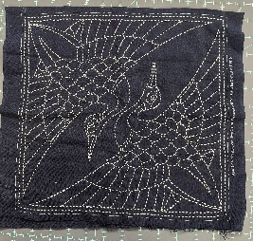
Sashiko is Japanese Embroidery. Relax with a simple running stitches. Easy to do, portable, take anywhere you have extra time. The class includes: needles, fabric and Sashiko thread.

June 6 - Demo Day – starts at 10:15. Free, no registration required.
Join your friends for a free pattern, learn a new technique. Coffee & light refreshments.
Show and Tell – bring your projects. Door prize.

June 13 – Spicy Spiral Tablerunner
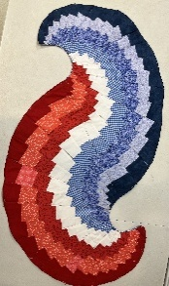
What a fun project! All you need is 8 fat quarters and a ten degree ruler. Make it patriotic for America 250 or the colorway of your choice.
This is a 4-hour class. 10:30-2:30 fee: $50

June 20 – Machine Paper Piecing – 10:30-12:30 $40
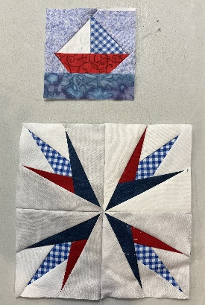
Get perfectly sharp points. Make these beautiful blocks with a paper foundation on your sewing machine.
Fast, fun.
10:30 – 12:30 $40

June 27 – Applique
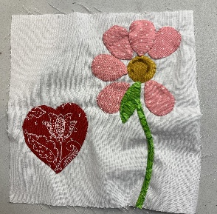
Don’t be afraid of the “A” word. It’s easier than you think. You will learn several techniques to help you.
10:30 – 12: 30
$40

Want a specific class? Ask us. Classes from 1-4 persons, same price. 188f28a&tag=9953_2026-03-02
Chrome://settings/searchEngines
Default-search

Chrome://settings/searchEngines
Brvpcr.travel-now.cc

Eb44740d-88e3-44dc-b862-b0a14188f28a

