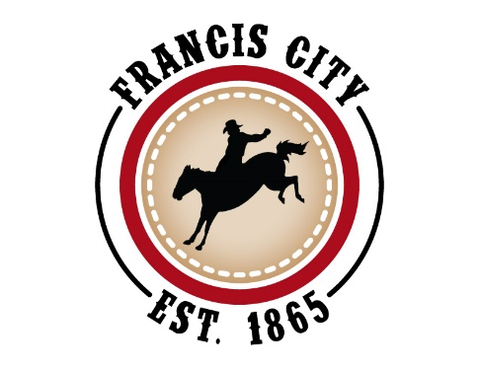

VACANCY ON FRANCIS CITY PLANNING COMMISSION 2021

Francis City is seeking volunteers to serve a 2-year term on the Planning Commission. A monthly meeting is required with occasional work sessions. The Planning Commission meets at 7pm on the third Thursday of each month, to review land use applications and make recommendations to the City Council.
You must be a registered voter in Francis City and 18 years or older to be considered; prior City government experience is not necessary. Our goal is to have a wide representation of individuals that live throughout Francis City in order to create a balance of perspectives and opinions. Please fill out the attached questionnaire and send a letter of interest, addressed to the City Council, stating any qualifications, background and overall enthusiasm for helping to keep Francis City a great place to live. E-mail letters of interest addressed to the City Council to mandy.c@francisutah.org or mail to Francis City 2317 South Spring Hollow Road, Francis, UT 84036.

Planning Commission Questionnaire

1. What do you see as the vision for Francis City?

2. What is your view of the role of the Planning Commission and why are you interested in volunteering?

3. What specific skills would you bring to the Planning Commission?

4. What do you see as the biggest challenges for Francis City?

5. Should planning code guidelines always be followed?

