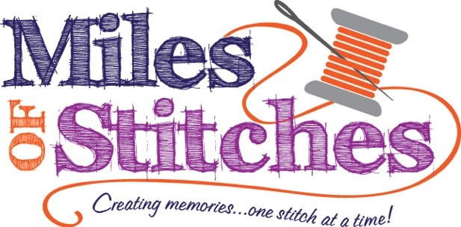

26.10.15: All The Things Tote

Thursday, October 15, 2026

10:00am – 2:00pm

$20.00, plus supplies

Join us for a fun and practical sewing class featuring the All the Things Tote pattern by Knot & Thread Design. This roomy tote is perfect for carrying sewing projects, class supplies, groceries, travel essentials, or everyday items while giving you the opportunity to create a beautiful handmade bag.

Class Supply List

- All The Things Tote Pattern
- Main Fabric: 1 yard
- Lining Fabric: 1 yard
- Accent Fabric: ¾ yard
- Foam Stabilizer: 1 yard
- 1 1/2” Webbing: 1 ¾ yard
- Hardware: 1” slider
- Basic Sewing Supplies

Please bring a sewing machine in good working order, basic sewing supplies, rotary cutting tools, thread, fabric and supplies as listed above.

Payment is required at registration. You may register in person, on our website, or by phone. Early registration is encouraged to reserve your spot. Supply lists are available online and in the store. Refunds are issued only if the class is canceled. Store credit will be given for cancellations made more than 48 hours before the scheduled class. Refunds are not available for cancellations made less than 48 hours before class or for no-shows.

