Pieceful Quilting, Inc.
Creative Inspiration One Block at a Time
3027 Jericho Turnpike
East Northport NY 11731
631-670-6254
www.piecefulquilting.com
Scalloped Placemats
Date and Time of Class: ___________________________________________
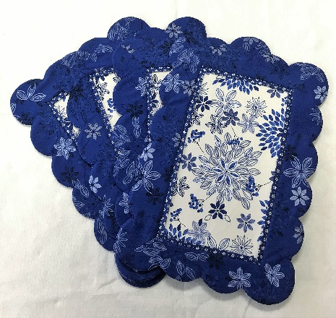
ALL SUPPLIES ARE AVAILABLE AT PIECEFUL QUILTING
REQUIRED:
Scalloped Placemats Pattern.

Fabric for 4 placemats:
Two color mats
1 3/8 yards for front and border
1 1/8 yards for accent and back

Four color mats
7/8 yard for front
¾ yard for border
1/3 yard for accent
7/8 yard for back

Foam – 4 precut placemats

Equipment:
Sewing Machine in good working order. New microtext or sharp 80/12 needles and full bobbin, small scissors, seam ripper, marking pen or pencil, rotary cutter, mat and ruler.
Wonder clips, Walking foot optional, Non stick pressing sheet, Point turner or purple thang
Best Press, Fray check, Matching threads

HOME WORK
Cut Sections for 4 placemats according to the instructions in the pattern.
Front, Borders, Accent, and Back

CLASS POLICY
Payment is required upon registration. Store credit is given for any class you cannot attend only if Pieceful Quilting is notified one week prior to the class, afterward only if a replacement student can be found. No store credit will be given to students who cancel less than one week before class for any reason. Be sure to pick up the items on your supply list prior to class so you can be prepared with supplies and fabrics. Supply lists will be distributed when you register for the class. For classes cancelled by Pieceful Quilting you will receive a store credit or refund by check.

