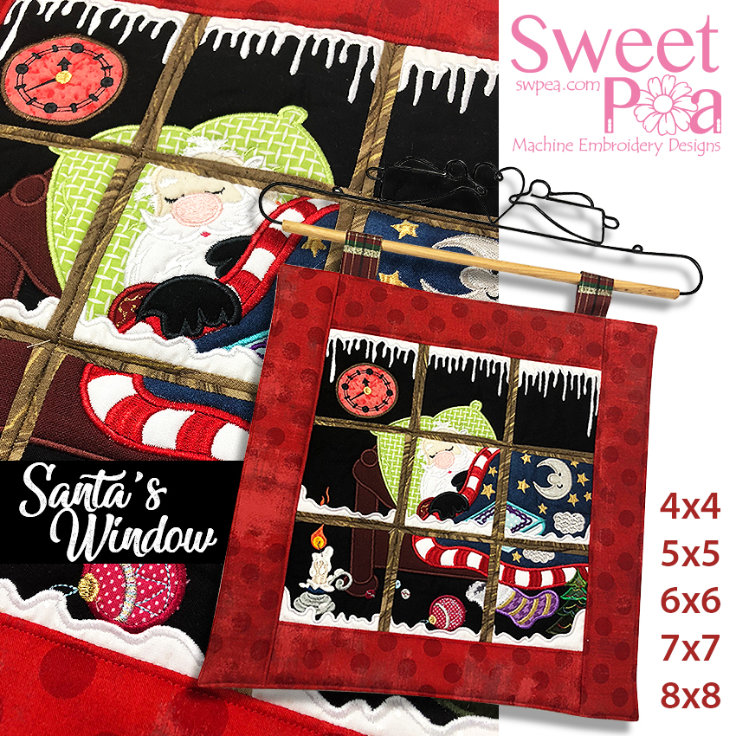

Santa’s Window 4x4 5x5 6x6 7x7 8x8 instructions

FABRIC REQUIREMENTS

4x4 (10cm x 10cm)
ALL PANELS
Fabric A - Strips of fabric for Window frames - 3cm x 15cm (1.5” x 6”)
- You will need 2 for Blocks 1, 3, 7 and 9
- You will need 3 for Blocks 2, 4, 6 and 8
- You will need 4 for Block 5

Batting 1 - 16cm x 16cm (6” x 6”) - cut one for each panel
Ribbon for loops - optional

BLOCK 1
Fabric B - 16cm x 16cm (6” x 6”) Background
Fabric C - 8cm x 8cm (3” x 3”) Clock
Fabric D - 4cm x 13cm (1.5” x 5”) Snow
Small piece of fabric for the applique: Corner of the pillow

BLOCK 2
Fabric B - 16cm x 16cm (6” x 6”) Background
Fabric C - 6cm x 10cm (2.5” x 4”) Pillow
Fabric D - 4cm x 11cm (1.5” x 4.5”) Snow
Small piece of fabric for the applique: Santa’s head

BLOCK 3
Fabric B - 16cm x 16cm (6” x 6”) Background
Fabric C - 5cm x 11cm (2” x 4.5”) Snow

BLOCK 4
Fabric B - 11cm x 11cm (4.5” x 4.5”) Background
Fabric C - 6cm x 9cm (2.5” x 3.5”) Bed
Fabric D - 6cm x 10cm (2.5” x 4”) Pillow
Fabric E - 6cm x 11cm (2” x 4.5”) Snow

BLOCK 5
Fabric B - 10cm x 11cm (4” x 4.5”) Pillow
Fabric C - 6cm x 11cm (2.5” x 4.5”) Blanket
Fabric D - 5cm x 15cm (2” x 5.5”) Blanket Trim
Fabric E - 4cm x 2cm (1.5” x 4.5”) Snow
Small pieces of fabric for the applique: Santa’s face, beard, gloves, sleeve & book

BLOCK 6
Fabric B - 16cm x 16cm (6” x 6”) Blanket
Fabric C - 5cm x 16cm (2” x 6”) Snow
Small pieces of fabric for the applique: Moon, book

BLOCK 7
Fabric B - 16cm x 16cm (6” x 6”) Background
Fabric C - 6cm x 9cm (2.5” x 3.5”) Bed
Fabric D - 5cm x 13cm (2” x 5”) Snow

BLOCK 8
Fabric B - 8cm x 11cm (3” x 4.5”) Background
Fabric C – 6cm x 11cm (2.5” x 4.5”) Bed
Fabric D - 6cm x 11cm (2.5” x 4.5”) Blanket Trim
Fabric E - 5cm x 11cm (2” x 4.5”) Snow
Small pieces of fabric for the applique: Blanket, Bauble

BLOCK 9
Fabric B - 9cm x 11cm (3.5” x 4.5”) Background
Fabric C - 5cm x 11cm (2” x 4.5”) Blanket
Fabric D - 5cm x 11cm (2” x 4.5”) Blanket Trim
Fabric E - 8cm x 11cm (3” x 4.5”) Snow
Small pieces of fabric for the applique: 4 x Christmas tree, stocking, corner of the book
REST OF THE WINDOW
Fabric F - cut 2 - 9cm x 33cm (3.5” x 13”) end borders (cut later - measure your joined blocks first)
Fabric G - cut 2 - 9cm x 46cm (3.5” x 18”) side borders (cut later - measure your joined blocks first)
Fabric H - cut 1 - 46cm x 46cm (18” x 18”) the backing (cut later - measure your joined blocks first)

Batting 2 - cut 2 - 9cm x 33cm (3.5” x 13”) end borders
Batting 3 - cut 2 - 9cm x 46cm (3.5” x 18”) side borders

Finished dimensions (approx.) - 43cmW x 43cmL (17” x 17”)

5x5 (13cm x 13cm)
ALL PANELS
Fabric A - Strips of fabric for Window frames - 3cm x 18cm (1.5” x 7”)
- You will need 2 for Blocks 1, 3, 7 and 9
- You will need 3 for Blocks 2, 4, 6 and 8
- You will need 4 for Block 5

Batting 1 - 18cm x 18cm (7” x 7”) - cut one for each panel
Ribbon for loops - optional

BLOCK 1
Fabric B - 16cm x 16cm (6” x 6”) Background
Fabric C - 10cm x 10cm (4” x 4”) Clock
Fabric D - 5cm x 16cm (2” x 6”) Snow
Small piece of fabric for the applique: Corner of the pillow

BLOCK 2
Fabric B - 16cm x 16cm (6” x 6”) Background
Fabric C - 8cm x 13cm (3” x 5”) Pillow
Fabric D - 4cm x 16cm (1.5” x 6”) Snow
Small piece of fabric for the applique: Santa’s head

BLOCK 3
Fabric B - 16cm x 16cm (6” x 6”) Background
Fabric C - 6cm x 16cm (2.5” x 6”) Snow

BLOCK 4
Fabric B - 16cm x 16cm (6” x 6”) Background
Fabric C - 10cm x 12cm (4” x 4.5”) Bed
Fabric D - 8cm x 12cm (3” x 4.5”) Pillow
Fabric E – 8cm x 16cm (3” x 6”) Snow

BLOCK 5
Fabric B - 13cm x 14cm (5” x 5.5”) Pillow
Fabric C - 8cm x 16cm (3” x 6”) Blanket
Fabric D - 6cm x 17cm (2.5” x 6.5”) Blanket Trim
Fabric E - 5cm x 16cm (2” x 6”) Snow
Small pieces of fabric for the applique: Santa’s face, beard, gloves, sleeve & book

BLOCK 6
Fabric B - 16cm x 16cm (6” x 6”) Blanket
Fabric C - 6cm x 16cm (2.5” x 6”) Snow
Small pieces of fabric for the applique: Moon, book

BLOCK 7
Fabric B - 16cm x 16cm (6” x 6”) Background
Fabric C - 8cm x 10cm (3” x 4”) Bed
Fabric D - 8cm x 16cm (3” x 6”) Snow

BLOCK 8
Fabric B - 9cm x 16cm (3.5” x 6”) Background
Fabric C - 8cm x 16cm (3” x 6”) Bed
Fabric D - 8cm x 13cm (3” x 5”) Blanket Trim
Fabric E - 5cm x 16cm (2” x 6”) Snow
Small pieces of fabric for the applique: Blanket, Bauble
BLOCK 9
Fabric B - 10cm x 16cm (4” x 6”) Background
Fabric C - 5cm x 16cm (2” x 6”) Blanket
Fabric D - 5cm x16cm (2” x 6”) Blanket Trim
Fabric E - 8cm x 16cm (3” x 6”) Snow
Small pieces of fabric for the applique: 4 x Christmas tree, stocking, corner of the book

REST OF THE WINDOW
Fabric F - cut 2 - 9cm x 43cm (3.5” x 17.5”) end borders (cut later - measure your joined blocks first)
Fabric G - cut 2 - 9cm x 56cm (3.5” x 22”) side borders (cut later - measure your joined blocks first)
Fabric H - cut 1 - 56cm x 56cm (22” x 22”) the backing (cut later - measure your joined blocks first)

Batting 2 - cut 2 - 9cm x 43cm (3.5” x 17.5”) end borders
Batting 3 - cut 2 - 9cm x 56cm (3.5” x 22”) side borders

Finished dimensions (approx.) - 51cmW x 51cmL (20.5” x 20.5”)

6x6 (16cm x 16cm)
ALL PANELS
Fabric A - Strips of fabric for Window frames - 4cm x 20cm (1.5” x 8”)
- You will need 2 for Blocks 1, 3, 7 and 9
- You will need 3 for Blocks 2, 4, 6 and 8
- You will need 4 for Block 5

Batting 1 - 20cm x 20cm (8” x 8”) - cut one for each panel
Ribbon for loops - optional

BLOCK 1
Fabric B - 18cm x 18cm (7” x 7”) Background
Fabric C - 11cm x 11cm (4.5” x 4.5”) Clock
Fabric D - 4cm x 18cm (1.5” x 7”) Snow
Small piece of fabric for the applique: Corner of the pillow

BLOCK 2
Fabric B - 18cm x 18cm (7” x 7”) Background
Fabric C - 8cm x 14cm (3” x 5.5”) Pillow
Fabric D - 5cm x 18cm (2” x 7”) Snow
Small piece of fabric for the applique: Santa’s head

BLOCK 3
Fabric B - 18cm x 18cm (7” x 7”) Background
Fabric C - 8cm x 18cm (3” x 7”) Snow

BLOCK 4
Fabric B - 18cm x 18cm (7” x 7”) Background
Fabric C - 12cm x 14cm (4.5” x 5.5”) Bed
Fabric D - 9cm x 13cm (3.5” x 5”) Pillow
Fabric E - 6cm x 18cm (2.5” x 7”) Snow

BLOCK 5
Fabric B - 18cm x 18cm (7” x 7”) Pillow
Fabric C - 10cm x 16cm (4” x 6”) Blanket
Fabric D - 8cm x 20cm (3” x 8”) Blanket Trim
Fabric E - 6cm x 18cm (2” x 7”) Snow
Small pieces of fabric for the applique: Santa’s face, beard, gloves, sleeve & book

BLOCK 6
Fabric B - 18cm x 18cm (7” x 7”) Blanket
Fabric C - 6cm x 18cm (2.5” x 7”) Snow
Small pieces of fabric for the applique: Moon, book

BLOCK 7
Fabric B - 18cm x 18cm (7” x 7”) Background
Fabric C - 9cm x 12cm (3.5” x 4.5”) Bed
Fabric D - 9cm x 18cm (3.5” x 7”) Snow
BLOCK 8
Fabric B - 11cm x 18cm (4.5” x 7”) Background
Fabric C - 10cm x 18cm (4” x 7”) Bed
Fabric D - 8cm x 16cm (3” x 6”) Blanket Trim
Fabric E - 8cm x 18cm (3” x 7”) Snow
Small pieces of fabric for the applique: Blanket, Bauble

BLOCK 9
Fabric B - 14cm x 18cm (5.5” x 7”) Background
Fabric C - 5cm x 18cm (2” x 7”) Blanket
Fabric D - 6cm x 18cm (2.5” x 7”) Blanket Trim
Fabric E - 10cm x 18cm (4” x 7”) Snow
Small pieces of fabric for the applique: 4 x Christmas tree, stocking, corner of the book

REST OF THE WINDOW
Fabric F - cut 2 – 9cm x 51cm (3.5” x 20”) end borders (cut later - measure your joined blocks first)
Fabric G - cut 2 - 9cm x 66cm (3.5” x 26”) side borders (cut later - measure your joined blocks first)
Fabric H - cut 1 - 66cm x 66cm (26” x 26”) the backing (cut later - measure your joined blocks first)

Batting 2 - cut 2 - 9cm x 51cm (3.5” x 20”) end borders
Batting 3 - cut 2 - 9cm x 66cm (3.5” x 26”) side borders

Finished dimensions (approx.) - 58cmW x 58cmL (23” x 23”)

7x7 (18cm x 18cm)
ALL PANELS
Fabric A - Strips of fabric for Window frames - 5cm x 23cm (2” x 9”)
- You will need 2 for Blocks 1, 3, 7 and 9
- You will need 3 for Blocks 2, 4, 6 and 8
- You will need 4 for Block 5

Batting 1 - 23cm x 23cm (9” x 9”) - cut one for each panel
Ribbon for loops - optional

BLOCK 1
Fabric B - 20cm x 20cm (8” x 8”) Background
Fabric C - 13cm x 13cm (5” x 5”) Clock
Fabric D - 5cm x 20cm (2” x 8”) Snow
Small piece of fabric for the applique: Corner of the pillow

BLOCK 2
Fabric B - 20cm x 20m (8” x 8”) Background
Fabric C - 10cm x 18cm (4” x 7”) Pillow
Fabric D - 5cm x 20cm (2” x 8”) Snow
Small piece of fabric for the applique: Santa’s head

BLOCK 3
Fabric B - 20cm x 20cm (8” x 8”) Background
Fabric C - 8cm x 20cm (3” x 8”) Snow

BLOCK 4
Fabric B - 20cm x 20cm (8” x 8”) Background
Fabric C - 11cm x 15cm (4.5” x 5.5”) Bed
Fabric D - 9cm x 16cm (3.5” x 6”) Pillow
Fabric E - 8cm x 20cm (3” x 8”) Snow

BLOCK 5
Fabric B - 20cm x 20cm (8” x 8”) Pillow
Fabric C - 13cm x 21cm (5” x 8.5”) Blanket
Fabric D - 9cm x 21cm (3.5” x 8.5”) Blanket Trim
Fabric E - 6cm x 20cm (2.5” x 8”) Snow
Small pieces of fabric for the applique: Santa’s face, beard, gloves, sleeve & book

BLOCK 6
Fabric B - 20cm x 20cm (8” x 8”) Blanket
Fabric C - 6cm x 20cm (2.5” x 8”) Snow
Small pieces of fabric for the applique: Moon, book

BLOCK 7
Fabric B - 20cm x 20cm (8” x 8”) Background
Fabric C - 10cm x 15cm (4” x 5.5”) Bed
Fabric D - 9cm x 20cm (3.5” x 8”) Snow

BLOCK 8
Fabric B - 13cm x 20cm (5” x 8”) Background
Fabric C - 10cm x 20cm (4” x 8”) Bed
Fabric D - 9cm x 18cm (3.5” x 7”) Blanket Trim
Fabric E - 8cm x 20cm (3” x 8”) Snow
Small pieces of fabric for the applique: Blanket, Bauble

BLOCK 9
Fabric B - 17cm x 20cm (6.5” x 8”) Background
Fabric C - 6cm x 20cm (2.5” x 8”) Blanket
Fabric D - 8cm x 20cm (3” x 8”) Blanket Trim
Fabric E - 11cm x 20cm (4.5” x 8”) Snow
Small pieces of fabric for the applique: 4 x Christmas tree, stocking, corner of the book

REST OF THE WINDOW
Fabric F - cut 2 - 9cm x 58cm (3.5” x 23”) end borders (cut later - measure your joined blocks first)
Fabric G - cut 2 - 9cm x 74cm (3.5” x 29”) side borders (cut later - measure your joined blocks first)
Fabric H - cut 1 - 74cm x 74cm (29” x 29”) the backing (cut later - measure your joined blocks first)

Batting 2 - cut 2 - 9cm x 58cm (3.5” x 23”) end borders
Batting 3 - cut 2 - 9cm x 74cm (3.5” x 29”) side borders

Finished dimensions (approx.) - 66cmW x 66cmL (26” x 26”)

8x8 (20cm x 20cm)
ALL PANELS
Fabric A - Strips of fabric for Window frames - 5cm x 25cm (2” x 10”)
- You will need 2 for Blocks 1, 3, 7 and 9
- You will need 3 for Blocks 2, 4, 6 and 8
- You will need 4 for Block 5

Batting 1 - 25cm x 25cm (10” x 10”) - cut one for each panel
Ribbon for loops - optional

BLOCK 1
Fabric B - 23cm x 23cm (9” x 9”) Background
Fabric C - 14cm x 14cm (5.5” x 5.5”) Clock
Fabric D - 6cm x 23cm (2.5” x 9”) Snow
Small piece of fabric for the applique: Corner of the pillow

BLOCK 2
Fabric B - 23cm x 23cm (9” x 9”) Background
Fabric C - 10cm x 19cm (4” x 7.5”) Pillow
Fabric D - 6cm x 23cm (2.5” x 9”) Snow
Small piece of fabric for the applique: Santa’s head

BLOCK 3
Fabric B - 23cm x 23cm (9” x 9”) Background
Fabric C - 9cm x 15cm (3.5” x 8.5”) Snow

BLOCK 4
Fabric B - 23cm x 23cm (9” x 9”) Background
Fabric C - 13cm x 17cm (5” x 6.5”) Bed
Fabric D - 11cm x 18cm (4.5” x 7”) Pillow
Fabric E - 8cm x 22cm (3” x 8.5”) Snow
BLOCK 5
Fabric B - 22cm x 22cm (8.5” x 8.5”) Pillow
Fabric C - 12cm x 22cm (4.5” x 8.5”) Blanket
Fabric D - 10cm x 24cm (4” x 9.5”) Blanket Trim
Fabric E - 8cm x 22cm (3” x 8.5”) Snow
Small pieces of fabric for the applique: Santa’s face, beard, gloves, sleeve & book

BLOCK 6
Fabric B - 23cm x 23cm (9” x 9”) Blanket
Fabric C - 8cm x 22cm (3” x 8.5”) Snow
Small pieces of fabric for the applique: Moon, book

BLOCK 7
Fabric B - 23cm x 23cm (9” x 9”) Background
Fabric C - 12cm x 15cm (4.5” x 5.5”) Bed
Fabric D - 10cm x 22cm (4” x 8.5”) Snow

BLOCK 8
Fabric B - 14cm x 23cm (5.5” x 9”) Background
Fabric C - 10cm x 22cm (4” x 8.5”) Bed
Fabric D - 10cm x 22cm (4” x 8.5”) Blanket Trim
Fabric E - 8cm x 22cm (3” x 8.5”) Snow
Small pieces of fabric for the applique: Blanket, Bauble

BLOCK 9
Fabric B - 14cm x 23cm (5.5” x 8.5”) Background
Fabric C - 8cm x 23cm (3” x 9”) Blanket
Fabric D - 9cm x 23cm (3.5” x 9”) Blanket Trim
Fabric E - 12cm x 23cm (4.5” x 9”) Snow
Small pieces of fabric for the applique: 4 x Christmas tree, stocking, corner of the book

REST OF THE WINDOW
Fabric B - cut 2 - 9cm x 66cm (3.5” x 26”) end borders (cut later - measure your joined blocks first)
Fabric C - cut 2 - 9cm x 84cm (3.5” x 33”) side borders (cut later - measure your joined blocks first)
Fabric D - cut 1 - 84cm x 84cm (33” x 33”) the backing (cut later - measure your joined blocks first)

Batting 2 - cut 2 - 9cm x 66cm (3.5” x 26”) end borders
Batting 3 - cut 2 - 9cm x 84cm (3.5” x 33”) side borders

Finished dimensions (approx.) - 74cmW x 74cmL (29” x 29”)

INSTRUCTIONS

STITCH BLOCK 1

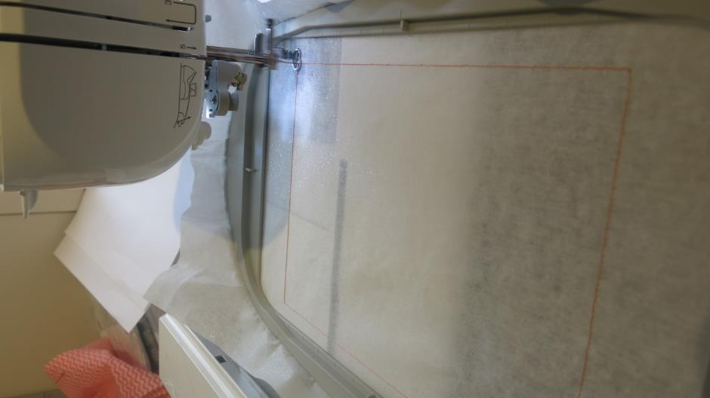
Hoop cutaway stabiliser in the hoop size you are making.

