Pieceful Quilting, Inc.
Creative Inspiration One Block at a Time

3027 Jericho Turnpike
East Northport NY 11731
631-670-6254
www.piecefulquilting.com

Itty Bitty Tote

Date and Time of Class: ___________________________________________
ALL SUPPLIES ARE AVAILABLE AT PIECEFUL QUILTING

Supplies:
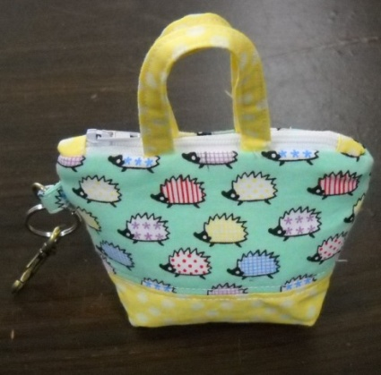
Itty Bitty Totes by Around the Bobbin
2 or 3 fat eighths or scraps!
¼ yard of Shir-tailor fusible interfacing
¼ yard of firm thin non-woven fusible interfacing IE Décor Bond.
Keychain Hardware Kit by Around the Bobbin
7 – 14 inch zipper to match or contrast
Sewing machine in good working order, new needle either 12 or 14 sharp, walking foot, zipper foot.
Basic Sewing Supplies including thread to match, removable fabric marker (water soluble, air erase or frixion), rotary cutting supplies.
CLASS POLICY
Payment is required upon registration. Store credit is given for any class you cannot attend only if Pieceful Quilting is notified one week prior to the class, afterward only if a replacement student can be found. No store credit will be given to students who cancel less than one week before class for any reason. Be sure to pick up the items on your supply list prior to class so you can be prepared with supplies and fabrics. Supply lists will be distributed when you register for the class. For classes cancelled by Pieceful Quilting you will receive a store credit or refund by check.

