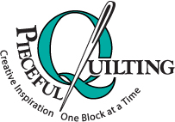
Pieceful Quilting, Inc.
Creative Inspiration One Block at a Time

3027 Jericho Turnpike
East Northport NY 11731
631-670-6254
www.piecefulquilting.com

Holiday Yo-Yo Towel

Date and Time of Class: ___________________________________________
ALL SUPPLIES ARE AVAILABLE AT PIECEFUL QUILTING
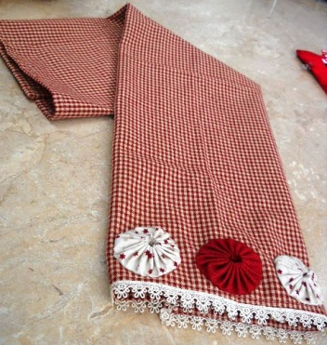
Supplies:
- Clover Yo-Yo maker size: Extra Large
- Gingham towel
- 5/8 yard trim for bottom edge of towel. (If you decide to use a different towel, make sure the piece of trim is long enough.)
- 7 fabric squares, 5 1/2" each to make the yo-yo's
- Quilting thread to make the yo-yo's
- Cotton thread to attach yo-yo's to mat
- Needle Threader
- Ruler
- Scissors, Tulip Piecing Needles, Flat Head straight pins

HOMEWORK:

Sew trim along the bottom of towel. Fold the edge of the trim at the beginning and the end.

Bring to class

CLASS POLICY
Payment is required upon registration. Store credit is given for any class you cannot attend only if Pieceful Quilting is notified one week prior to the class, afterward only if a replacement student can be found. No store credit will be given to students who cancel less than one week before class for any reason. Be sure to pick up the items on your supply list prior to class so you can be prepared with supplies and fabrics. Supply lists will be distributed when you register for the class. For classes cancelled by Pieceful Quilting you will receive a store credit or refund by check.

