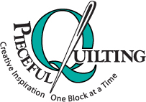
Pieceful Quilting, Inc.
Creative Inspiration One Block at a Time

3027 Jericho Turnpike
East Northport NY 11731
631-670-6254
www.piecefulquilting.com

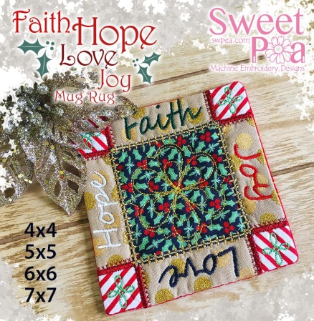
Embroidered Faith Hope Love Mug Rug
Date and Time of Class: ___________________________________________
ALL SUPPLIES ARE AVAILABLE AT PIECEFUL QUILTING
Embroidery Design will be available for purchase on YOUR Flash Drive on the day of class.
Fabric: See page 2 for fabric and batting requirements based on HOOP SIZE.
Bosal Cut Away Stabilizer – 1/2 yards
Equipment:
EMBROIDERY machine, owner’s manual, new embroidery needle 80/12, FULL Bobbin with bobbin thread, Frixion marking pen, thread in desired colors, seam ripper, curved scissors.

HOMEWORK

Cut out ALL fabric and batting pieces according to fabric requirement chart BASED ON YOUR HOOP SIZE.

CLASS POLICY
Payment is required upon registration. Store credit is given for any class you cannot attend only if Pieceful Quilting is notified one week prior to the class, afterward only if a replacement student can be found. No store credit will be given to students who cancel less than one week before class for any reason. Be sure to pick up the items on your supply list prior to class so you can be prepared with supplies and fabrics. Supply lists will be distributed when you register for the class. For classes cancelled by Pieceful Quilting you will receive a store credit or refund by check.

Faith Hope Love Joy Mug rug 4x4 5x5 6x6 7x7 Instructions

4x4 hoop (100mm x 100mm) hoop
Fabric A – 14cm x 14cm (6” x 6”) Front of mug rug
Fabric B – cut 4 - 5cm x 5cm (2” x 2”) four corners
Fabric C – 9cm x 9cm (3.5” x 3.5”) centre square
Fabric D – 14cm x 14cm (6” x 6”) Back of mug rug
Batting 1 – 14cm x 14cm (6” x 6”) Front of mug rug

5x5 hoop (130mm x 130mm) hoop
Fabric A – 17cm x 17m (7” x 7”) Front of mug rug
Fabric B - cut 4 - 7cm x 7cm (3” x 3”) four corners
Fabric C – 11cm x 11cm (4½” x 4½”) centre square
Fabric D – 17cm x 17m (7” x 7”) Back of mug rug
Batting 1 – 17cm x 17m (7” x 7”) Front of mug rug

6x6hoop (160mm x 160mm) hoop
Fabric A – 20cm x 20cm (8” x 8”) Front of mug rug
Fabric B – cut 4 - 7cm x 7cm (3” x 3”) four corners
Fabric C – 13cm x 13cm (5” x 5”) centre square
Fabric D – 20cm x 20cm (8” x 8”) Back of mug rug
Batting 1 – 20cm x 20cm (8” x 8”) Front of mug rug

7x7 hoop (180mm x 180mm) hoop
Fabric A – 22cm x 22cm (9” x 9”) Front of mug rug
Fabric B – cut 4 – 9cm x 9cm (3.5” x 3.5”) four corners
Fabric C – 15cm x 15cm (6” x 6”) centre square
Fabric D – 22cm x 22cm (9” x 9”) Back of mug rug
Batting 1 – 22cm x 22cm (9” x 9”) Front of mug rug

