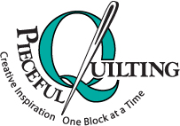
Pieceful Quilting, Inc.
Creative Inspiration One Block at a Time

3027 Jericho Turnpike
East Northport NY 11731
631-670-6254
www.piecefulquilting.com
Double Wedding Ring Bed Runner – pattern required
Date and Time of Class: ___________________________________________
ALL SUPPLIES ARE AVAILABLE AT PIECEFUL QUILTING

HOMEWORK
Cut small pieces for the wedding ring per pattern instructions

Fabric: For the three 20" rings:
Background 1 3/4 yards
Rings 1/4 yard of 7 colors or shades
Diamond accent 1/4 yard (this can be the same as one of the ring colors)

Equipment:
Pattern and foundation, Sewing machine, owner’s manual, new needle, threads to match, seam ripper, curved or appliqué scissors , pins, 12” square up ruler, washable glue stick (we like Bohin), Add a Quarter Ruler, Index card or card stock

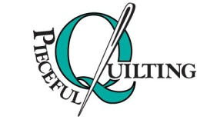
3027 Jericho Turnpike
East Northport NY 11731
(631) 670-6254

Thank you for choosing to take a class with us at Pieceful Quilting. This coupon entitles you to 10% off on any supplies you purchase here for your class.
(Does not include machines, furniture, Accuquilt products, other classes or already discounted products)
CLASS POLICY
Payment is required upon registration. Store credit is given for any class you cannot attend only if Pieceful Quilting is notified one week prior to the class, afterward only if a replacement student can be found. No store credit will be given to students who cancel less than one week before class for any reason. Be sure to pick up the items on your supply list prior to class so you can be prepared with supplies and fabrics. Supply lists will be distributed when you register for the class. For classes cancelled by Pieceful Quilting you will receive a store credit or refund by check.

